Kapture - MDM (Master Data Maintenance) Tools, Import and Export Unit Test Cases

Contents
1. User System Access 3
2. RUM VIN 4
3. CD ROM Creation 5
4. ESI Labels Update Schedule 18
5. MME Translation Update 19
6. RMI Export Tool 25
7. Service Information Data Import 34
8. MNAO Data Export Tool 39
9. MGSS Bulk Data Extract & Transfer Tool 48

Kapture - MDM (Master Data Maintenance) - Tools, Import and Export
Unit Test Cases
Application URL: https://na.dev.mgss.oc.mazda.com/mdmgt
Application: mdmgt.war (/mdmgt) | Version: v2 | Date: 17-Oct-2026
- Unit Test Case Summary:
# | Test Cases Processes | No. of Test Cases | No. of Success | No. of Failure | Status
1 | User System Access | 1 | 1 | 0 | Pass
2 | RUM VIN | 1 | 1 | 0 | Pass
3 | CD ROM Creation | 5 | 5 | 0 | Pass
4 | ESI Labels Update Schedule | 1 | 1 | 0 | Pass
5 | MME Translation Update | 3 | 3 | 0 | Pass
6 | RMI Export Tool | 4 | 4 | 0 | Pass
7 | Service Information Data Import | 3 | 3 | 0 | Pass
8 | MNAO Data Export Tool | 4 | 4 | 0 | Pass
9 | MGSS Bulk Data Extract & Transfer Tool | 3 | 3 | 0 | Pass
 | Total | 25 | 25 | 0 | Pass

User System Access
- User should be able to open MDM and view the Tools, Import and Export tab on My Page.
Steps:
1. Log in to MGSS with a valid user.
2. Open the URL: https://na.dev.mgss.oc.mazda.com/mdmgt
3. Click the Tools, Import and Export tab.
Expected Result: The tab lists the tiles RUM VIN, CD ROM Creation, ESI Labels Update Schedule, MME Translation Update, RMI Export Tool, Service Information Data Import, MNAO Data Export Tool and MGSS Bulk Data Extract & Transfer Tool.
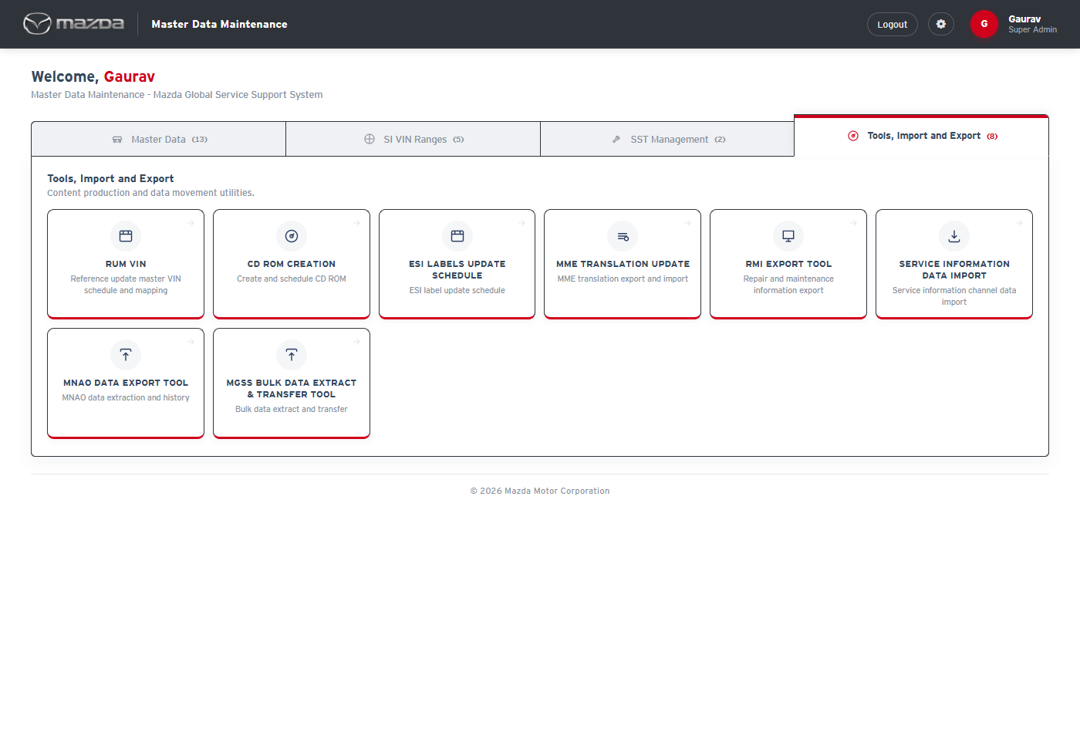
My Page - Tools, Import and Export tab
Status: Pass
Remarks:

RUM VIN
- User should be able to view the RUM VIN schedule history and the RUM VIN mappings.
Steps:
1. From My Page > Tools, Import and Export, click RUM VIN.
2. Click RUM VIN Mapping in the top menu.
Expected Result:
- RUM VIN Schedule lists the monthly schedules with schedule / finish time, line counts, file name, schedule status, job status and remarks.
- RUM VIN Mapping Details lists the VIN at RUSSIA to VIN at MAZDA mappings with creation and last modified time.
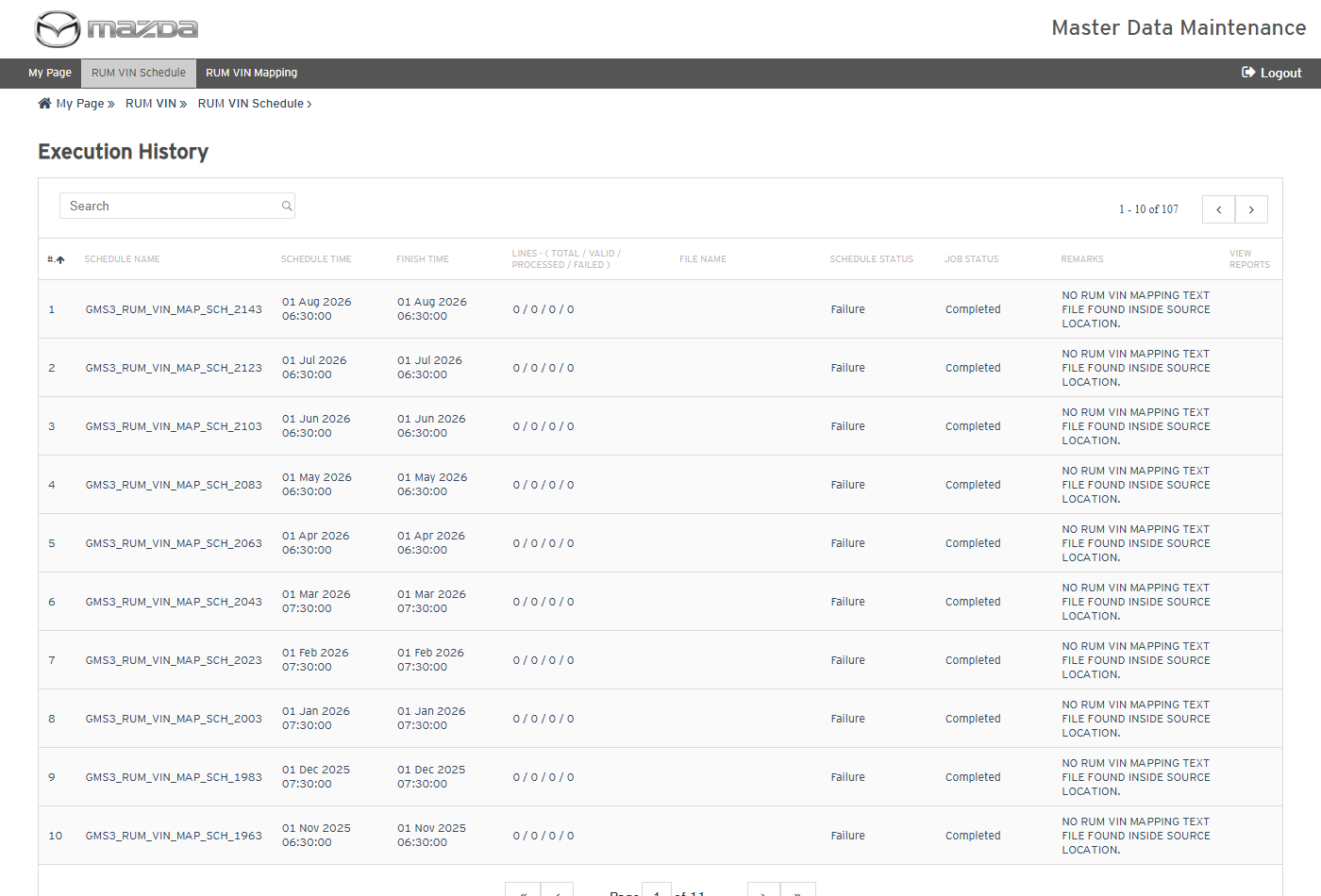
RUM VIN Schedule - Execution History
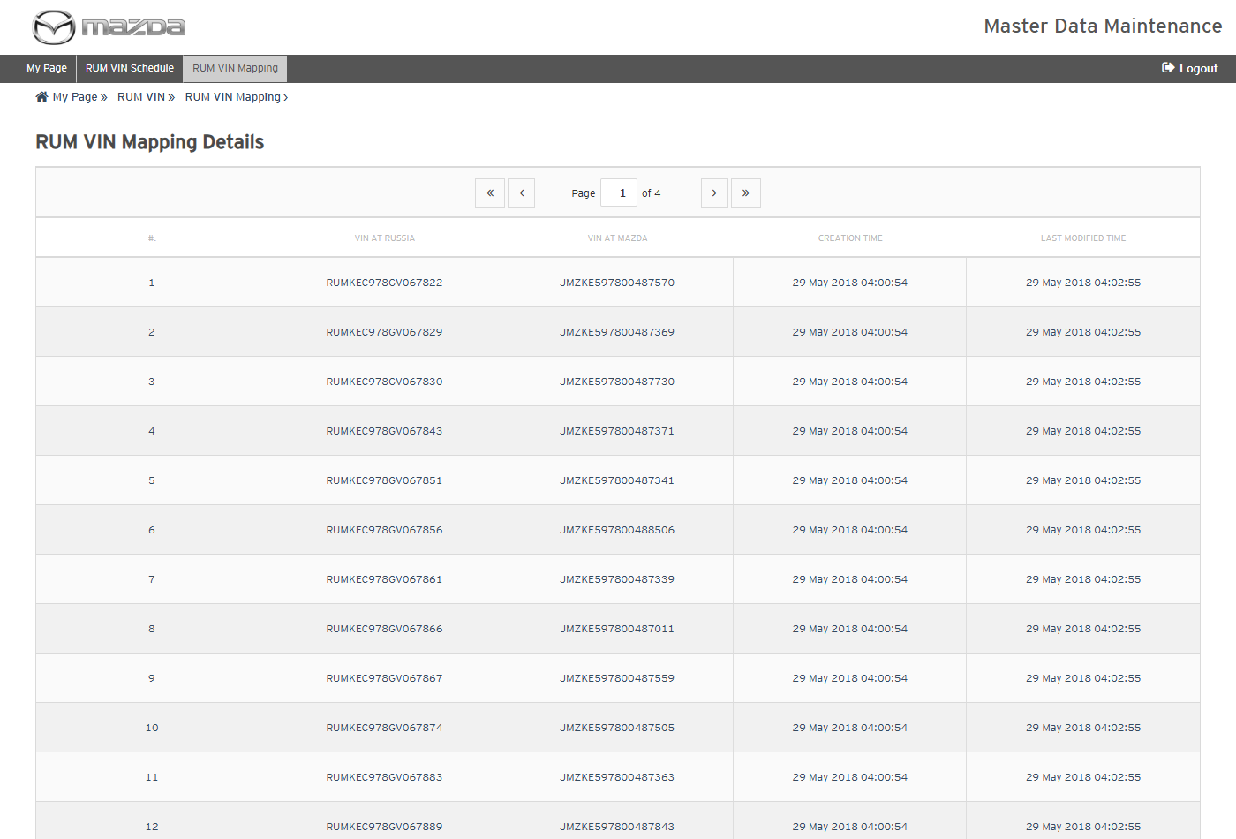
RUM VIN Mapping Details
Status: Pass
Remarks:

CD ROM Creation
CD ROM Creation builds an offline CD of the Service Manual / Wiring Diagram content of a VIN. The cases below are executed with Country Japan, Language Japanese, Model プレマシー(CR) and VIN - / CR3W / 100001.
- System should not search without the mandatory fields.
Steps:
1. From My Page > Tools, Import and Export, click CD ROM Creation.
2. Click Go.
Expected Result: "Please fill all the fields marked as mandatory (*)." is shown.
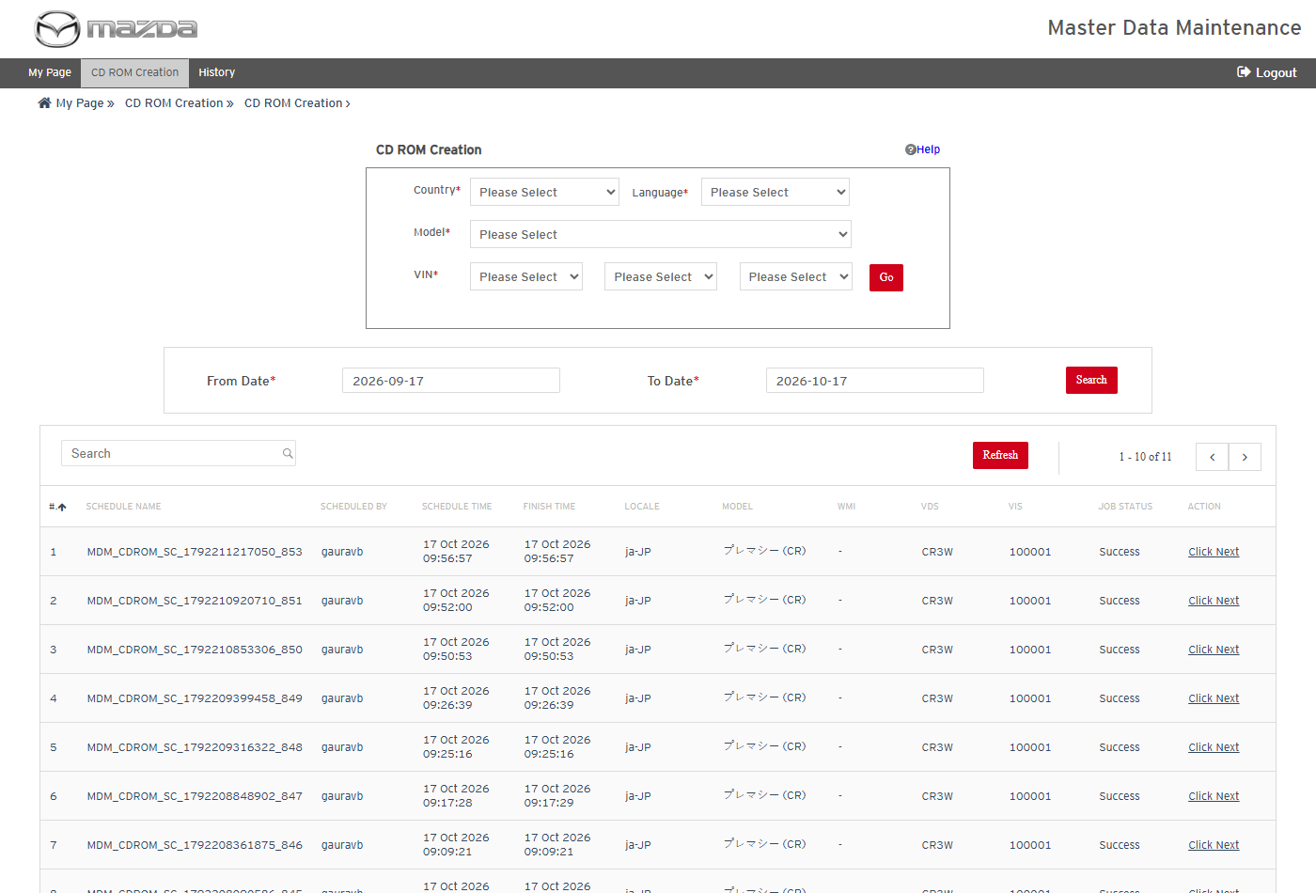
CD ROM Creation
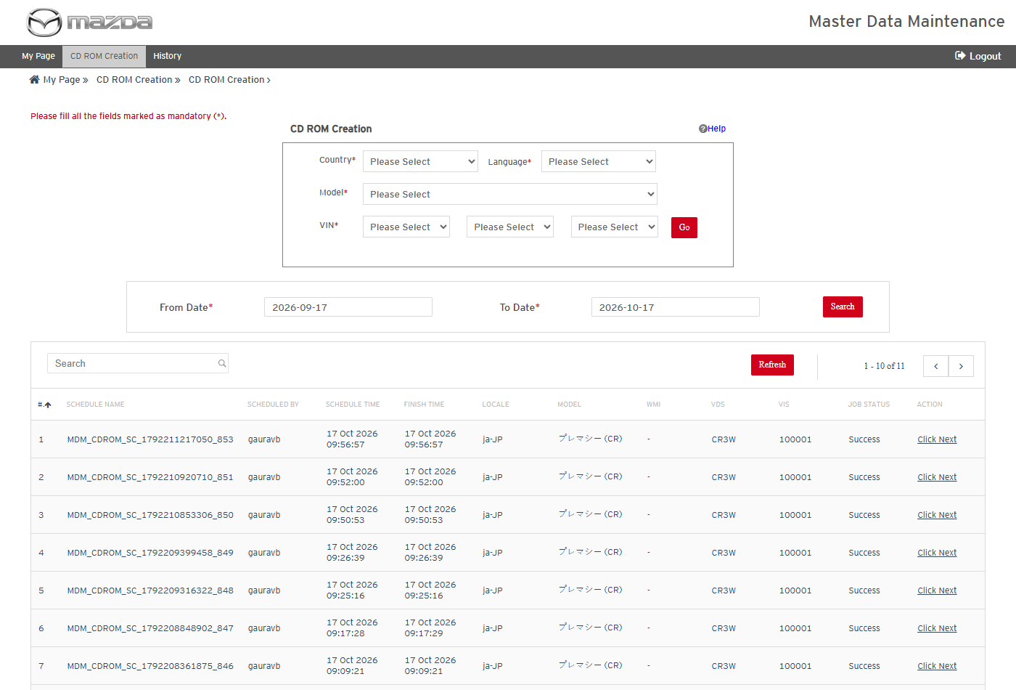
Mandatory field message
Status: Pass
Remarks:

- User should be able to search the manuals available for a VIN.
Steps:
1. Select Country Japan, Language Japanese, Model プレマシー(CR) and VIN - / CR3W / 100001.
2. Click Go.
Expected Result:
- A search schedule (MDM_CDROM_SC_...) is created and completes with job status Success.
- Click Next opens "Select a necessary item" with the Service Contents, Engine Workshop Manual and Transmission Workshop Manual available for the VIN.
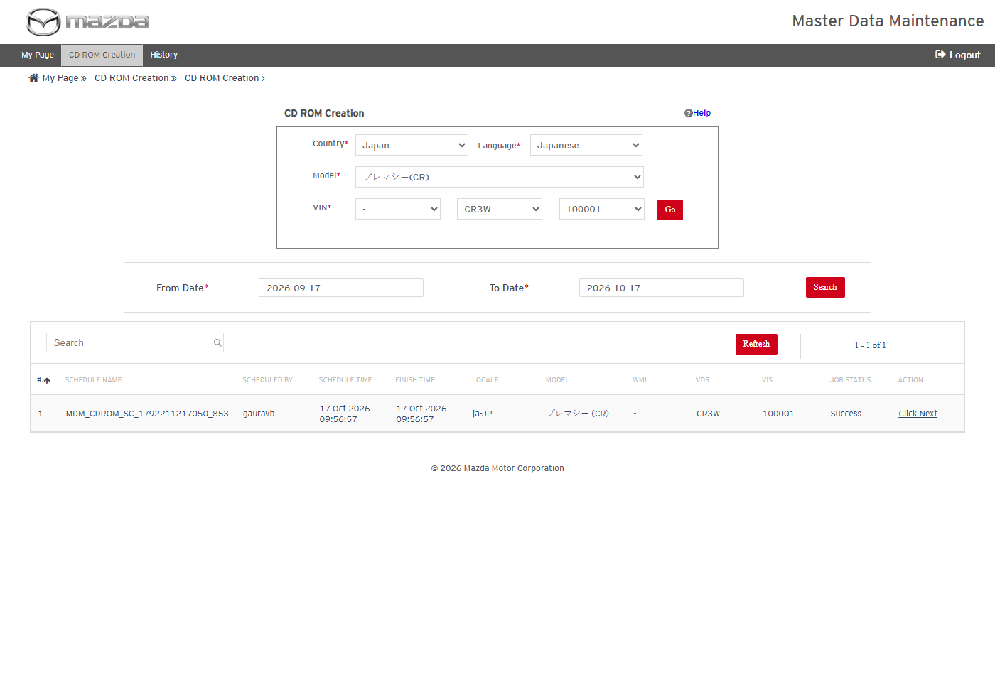
VIN selected
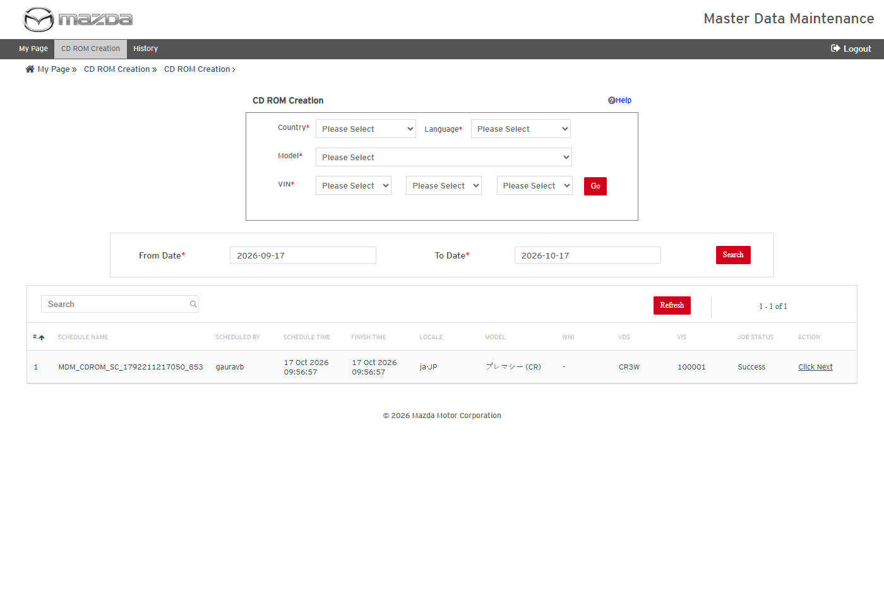
Search schedule completed
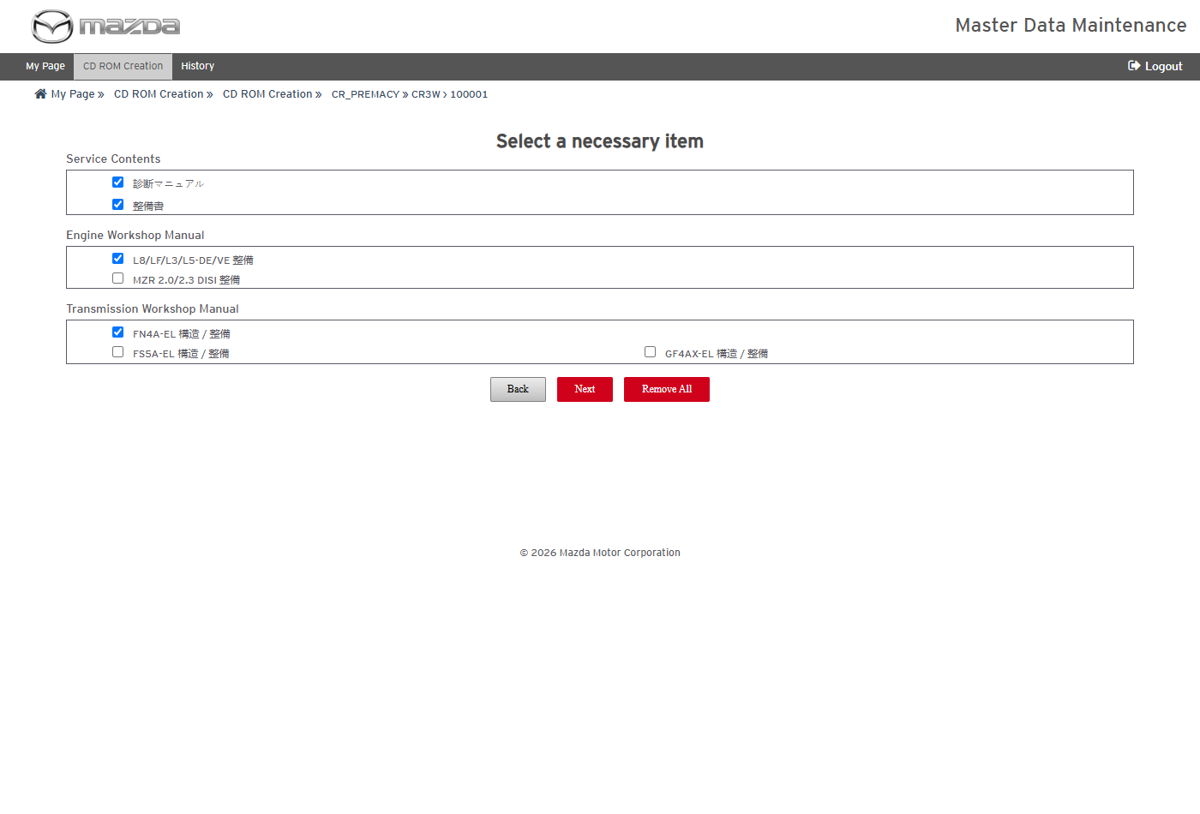
Select a necessary item
Status: Pass
Remarks:

- User should be able to select a manual and schedule the CD creation.
Steps:
1. Select only 整備書 (Workshop Manual) under Service Contents and click Next.
2. Check Total Docs for Processing and click Submit.
3. Click Schedule on the confirmation.
Expected Result:
- The selection page lists 整備書 with Total Docs for Processing 1.
- The CD creation is scheduled (MDM_CDROM_..._856) and processed in the background.
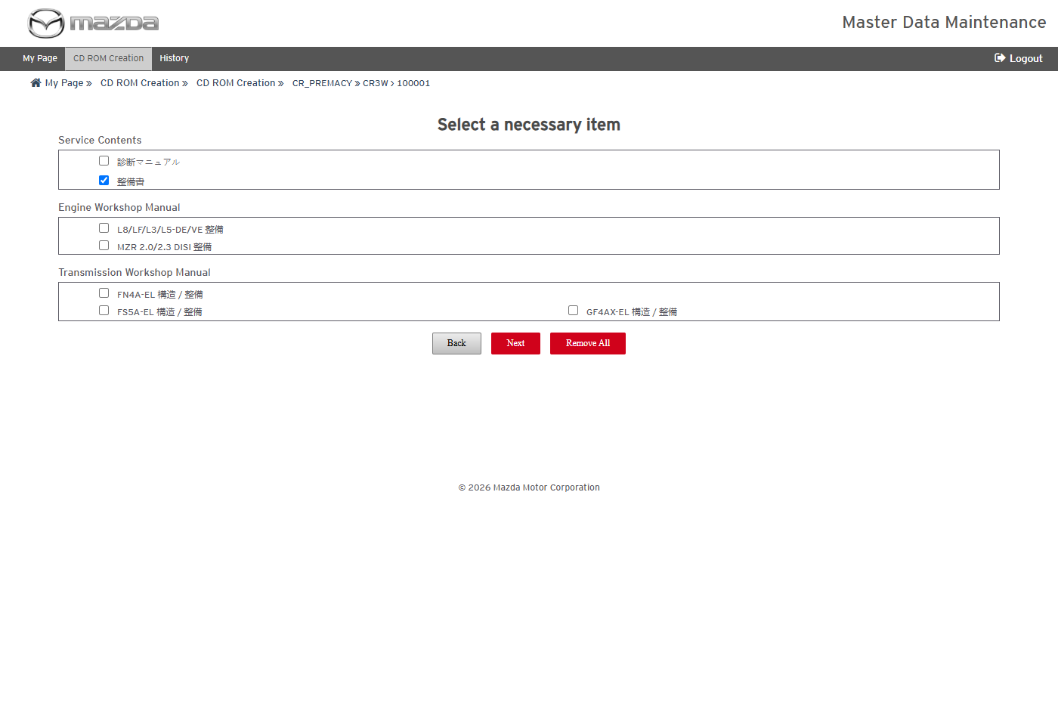
Manual selected
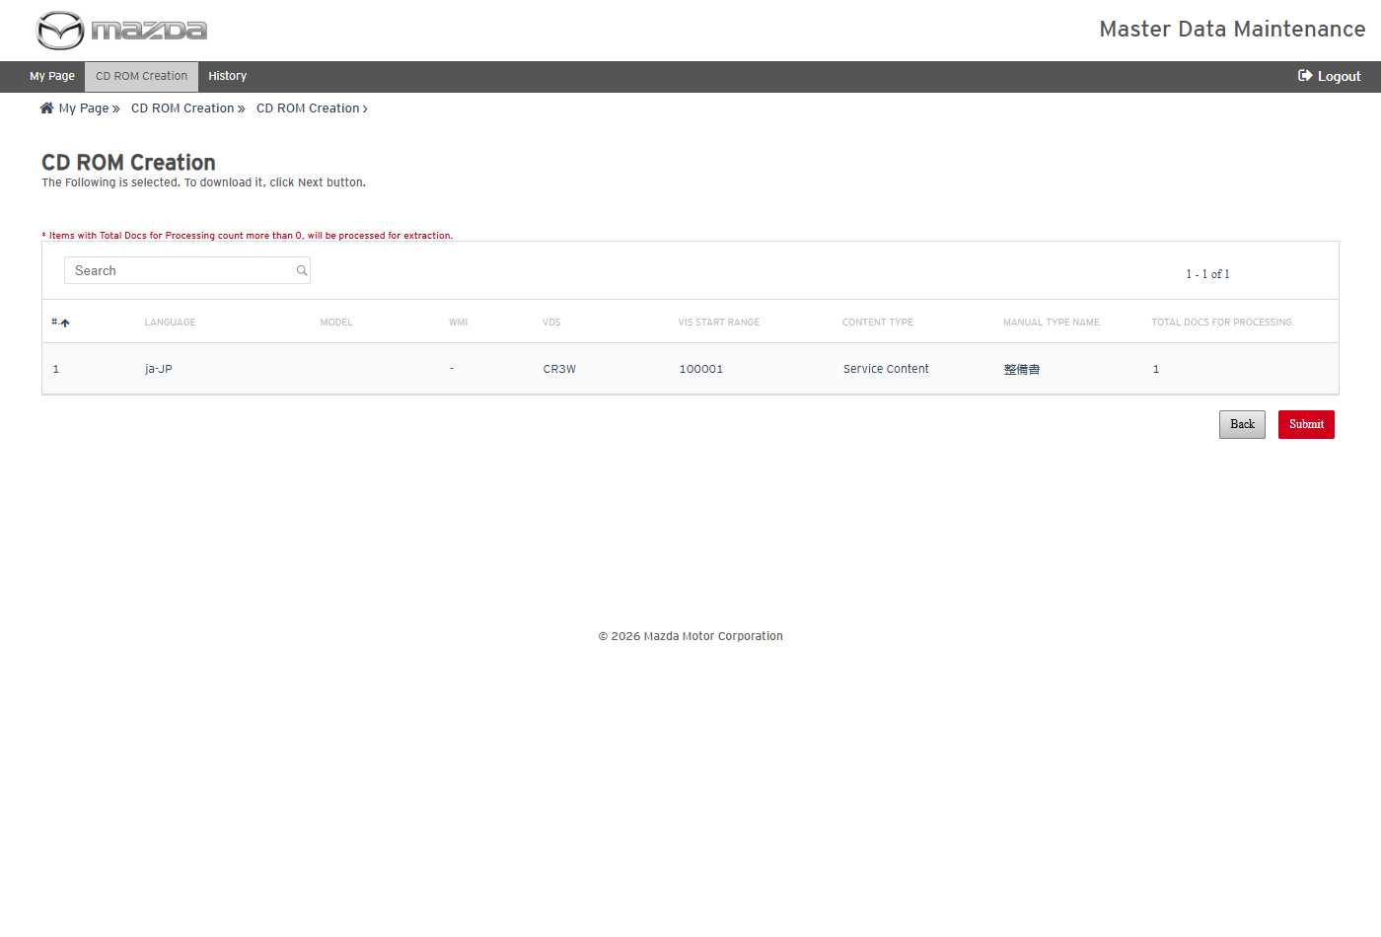
Selection summary
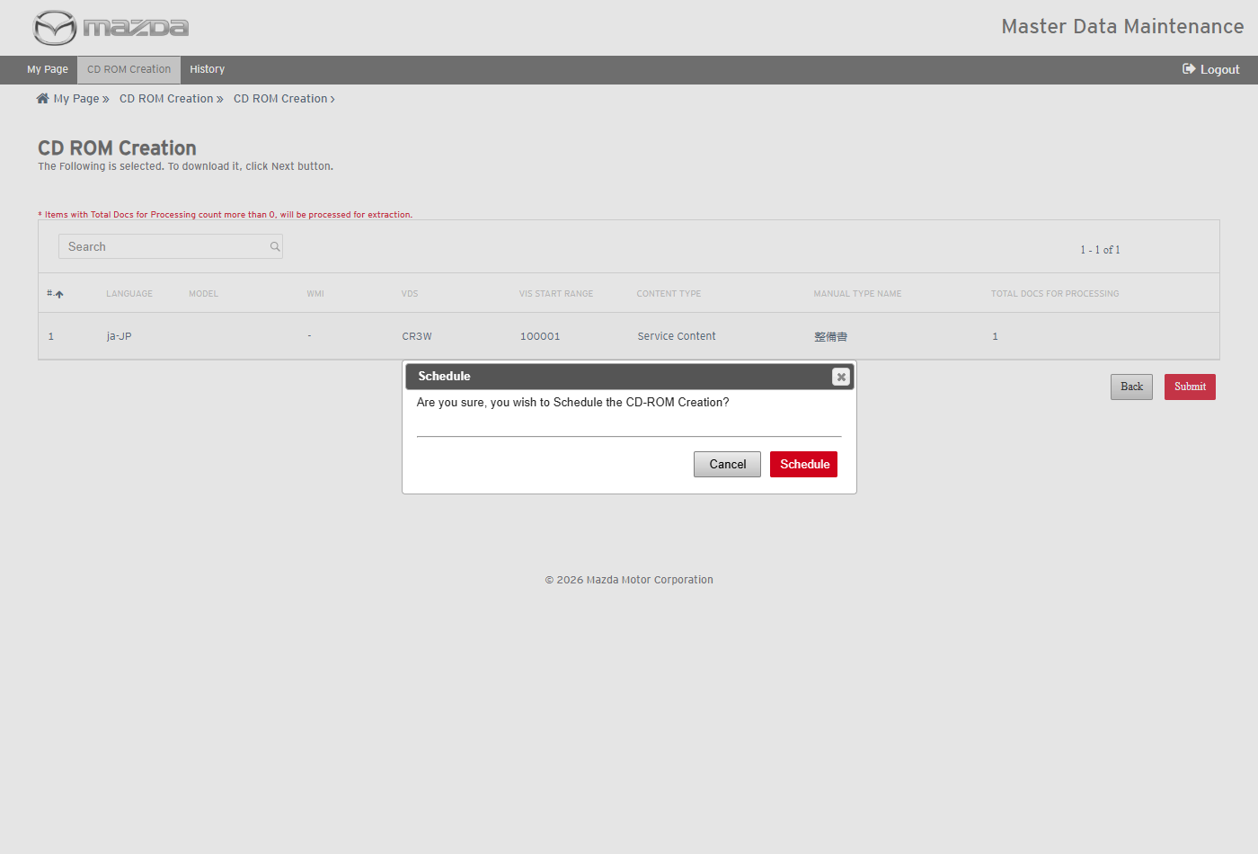
Schedule confirmation
Status: Pass
Remarks:

- User should be able to view the CD creation history and reports.
Steps:
1. Click History in the top menu.
2. Download the reports of the schedule.
Expected Result:
- The schedule shows Documents 1 / 1 / 0, OKAssets 2 / 2 / 0, Inner Links 0 / 0 / 0, Content Status COMPLETED and Job Status Success, with Download Contents / Reports and View CD ROM.
- The Transaction Report lists SM1558284 with Processing Status Success; the OKAsset Report lists both images copied.
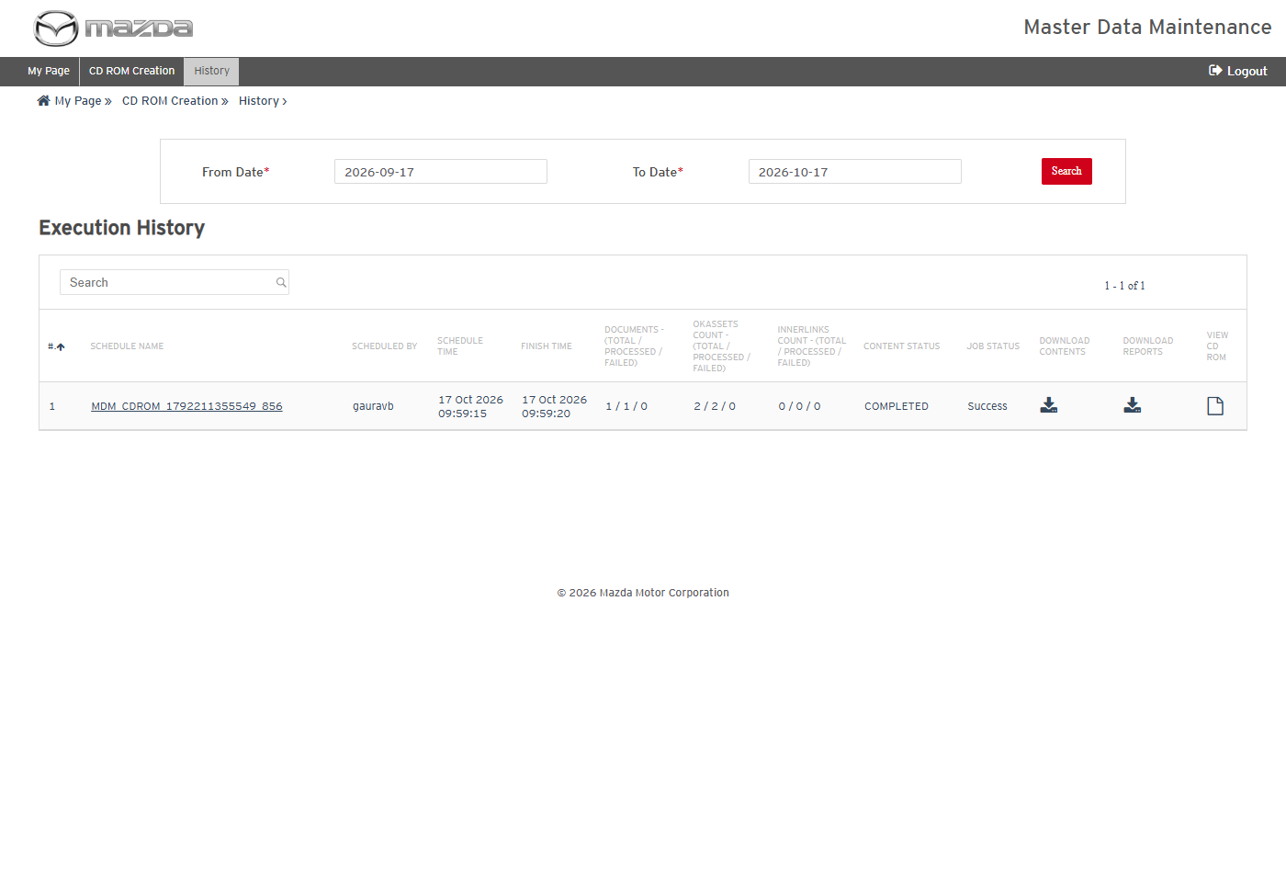
CD ROM Creation History
Transaction Report
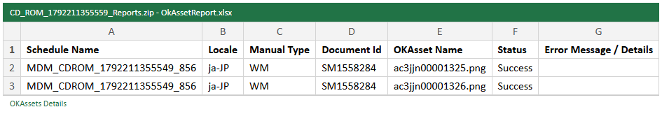
OKAsset Report
Status: Pass
Remarks:

- User should be able to view the created CD ROM in the browser.
Steps:
1. In History, click View CD ROM of the schedule.
2. Open the サービス資料 tab, expand the tree and open the document.
3. Enter クラッチ in キーワード検索 and click 検索.
Expected Result:
- The CD opens with the model / VIN label (プレマシー(CR) CR3W 100001).
- The tree lists 整備書 > B/P(黒桃色線) > クラッチ [C66M-R, C66MX-R]; the document opens with its text and images.
- The keyword search returns the document (合計 : 1).
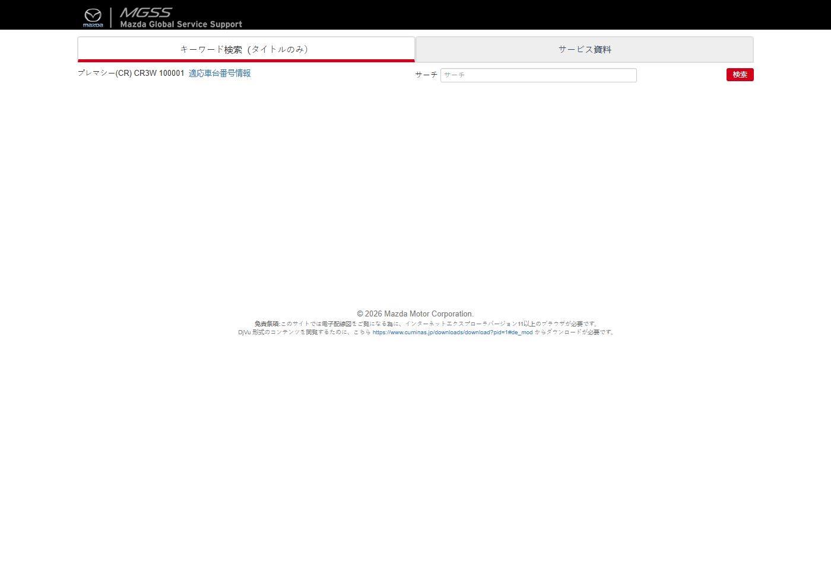
CD ROM - home
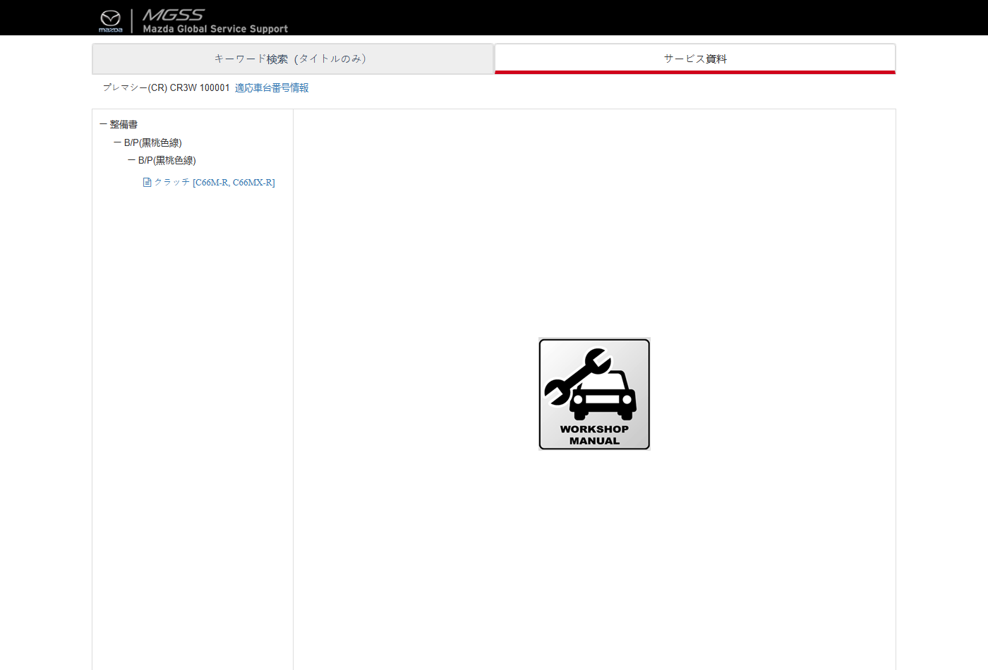
CD ROM - service materials tree
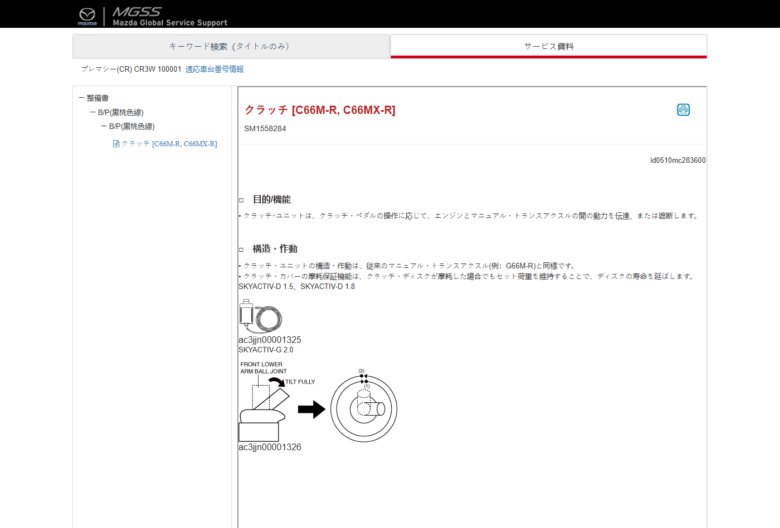
CD ROM - document
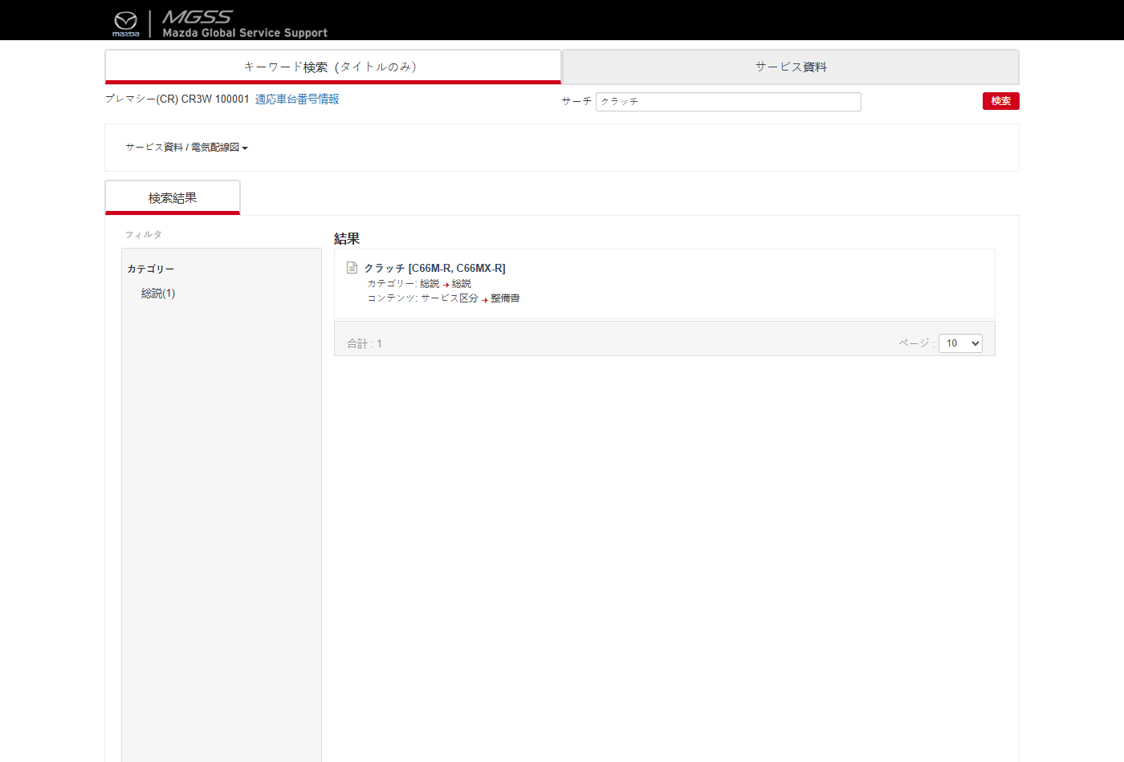
CD ROM - keyword search
Status: Pass
Remarks:

ESI Labels Update Schedule
- User should be able to view the ESI Labels Update schedule history.
Steps:
1. From My Page > Tools, Import and Export, click ESI Labels Update Schedule.
Expected Result: Execution History lists each schedule with schedule / finish time, document counts (total / processed / failed), schedule and job status, remarks and a View Reports download.
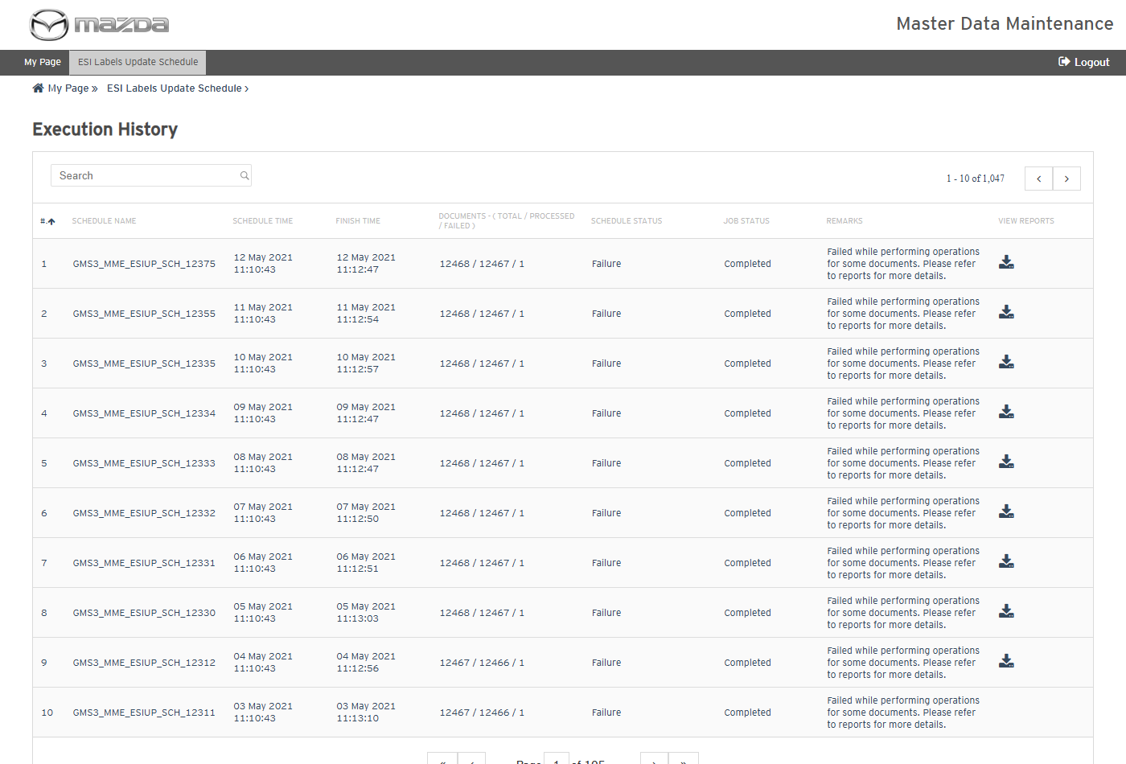
ESI Labels Update Schedule - Execution History
Status: Pass
Remarks:

MME Translation Update
The cases below are executed with Country United States and Language English Us for the Export operation (Import updates the documents in the same manner from the exported files).
- System should not validate without document ids.
Steps:
1. From My Page > Tools, Import and Export, click MME Translation Update.
2. Select the Country and Language and click Validate without document ids.
Expected Result: "Document Id is required. Please enter document id either using Input field or upload a valid excel." is shown.
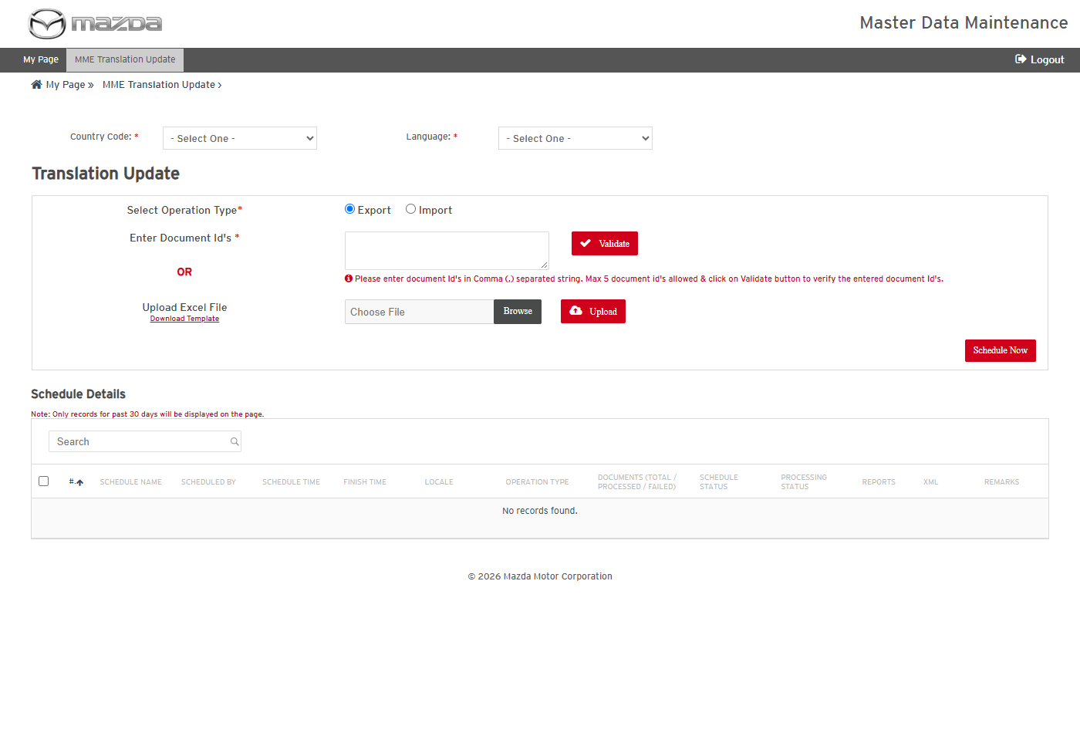
MME Translation Update
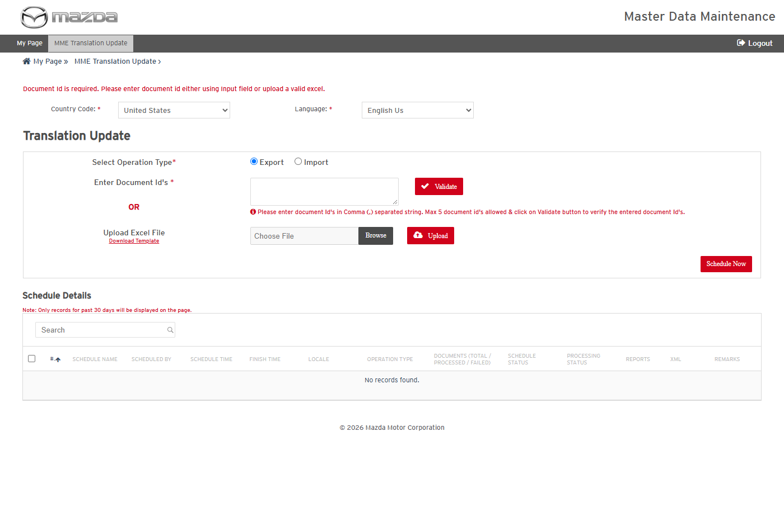
Validation message
Status: Pass
Remarks:

- User should be able to validate document ids and schedule a translation export.
Steps:
1. Select Operation Type Export and enter SI1123,SI1131.
2. Click Validate.
3. Click Schedule Now.
Expected Result:
- Documents to Export shows Total 2 / Success 2 / Failure 0.
- "MGSS_TU_402 scheduled successfully." is shown and the schedule completes with 2 / 2 / 0, Schedule Status Success, Processing Status Completed.
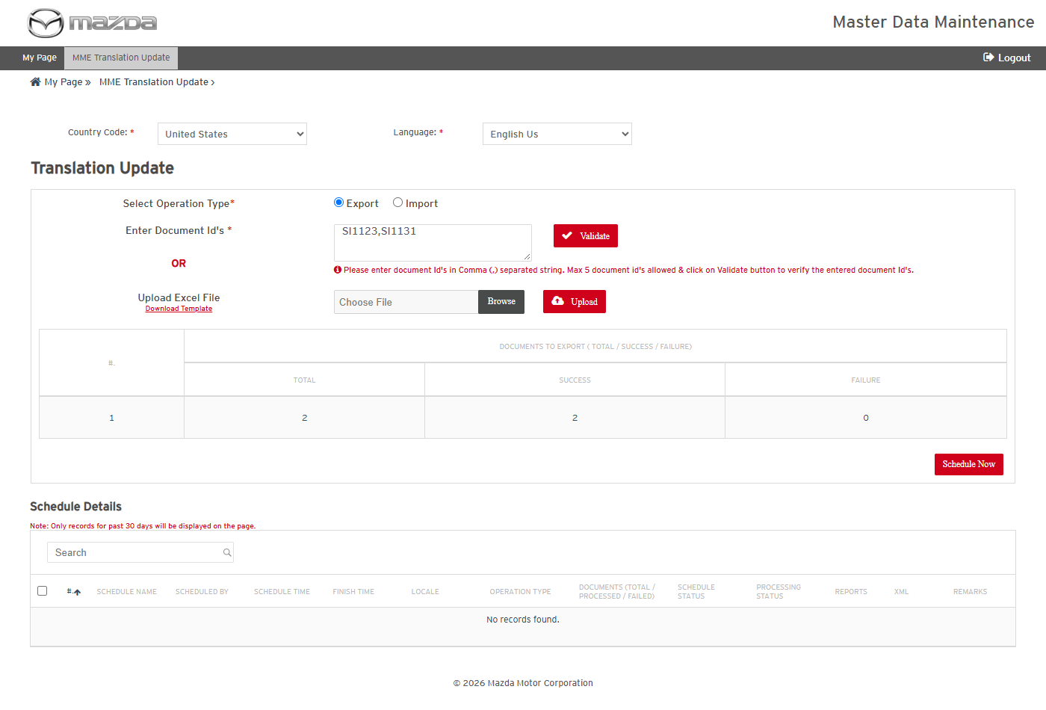
Document ids validated
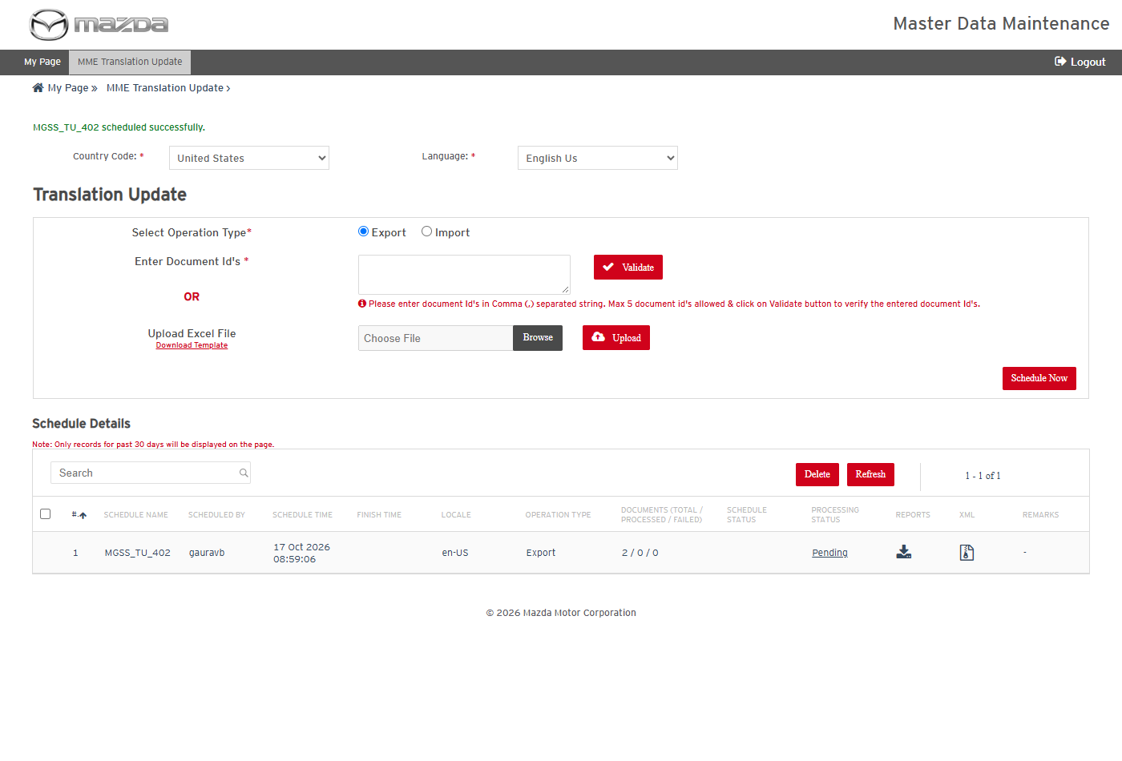
Export scheduled
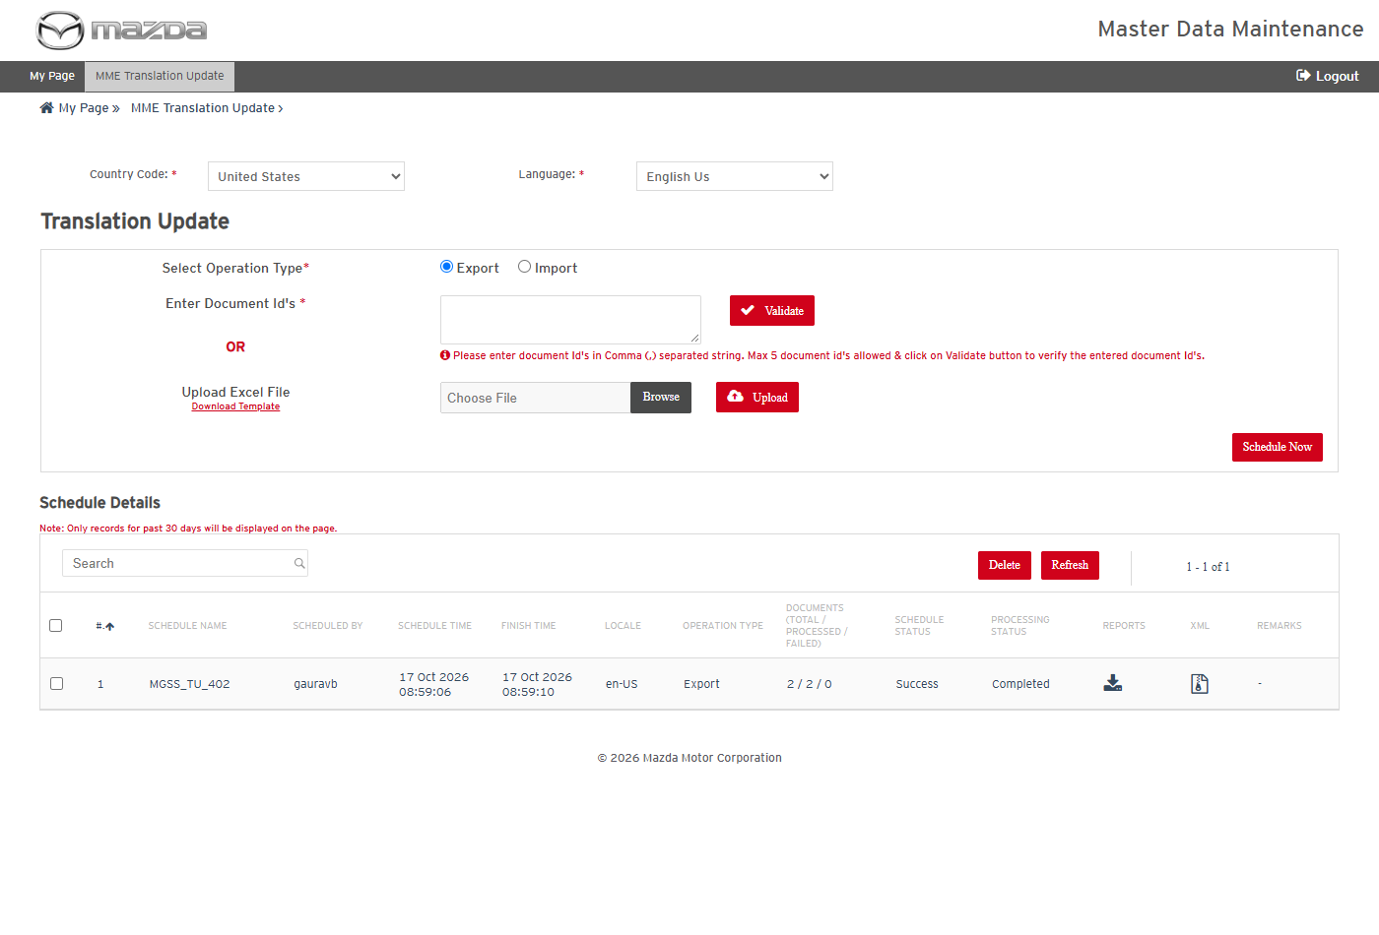
Export completed
Status: Pass
Remarks:

- User should be able to download the translation export report and XML.
Steps:
1. Click the Reports and XML download icons of MGSS_TU_402.
2. Open the files.
Expected Result:
- The transaction report lists SI1123 and SI1131 (en_US, Export) with Processing Status Success.
- The XML zip holds one XML per document with the translatable fields (title, history, summary, description, repair procedure and others).
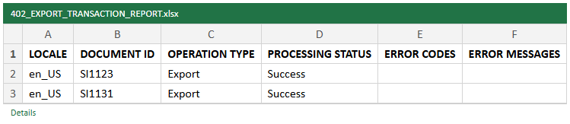
Export transaction report
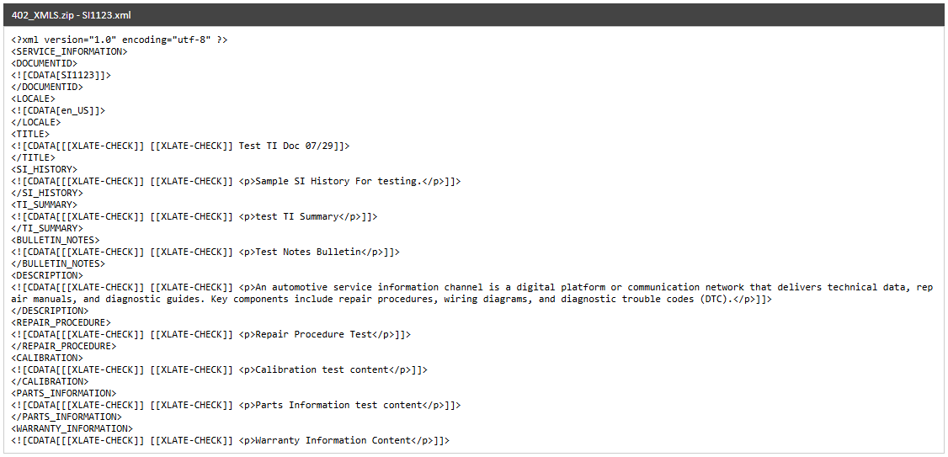
Exported XML - SI1123
Status: Pass
Remarks:

RMI Export Tool
The cases below are executed with Country United Kingdom, Language English (en-UK) and Model BT-50_UP.
- System should not list items without the mandatory fields.
Steps:
1. From My Page > Tools, Import and Export, click RMI Export Tool.
2. Click Go.
Expected Result: "Please fill all the fields marked as mandatory (*)." is shown.
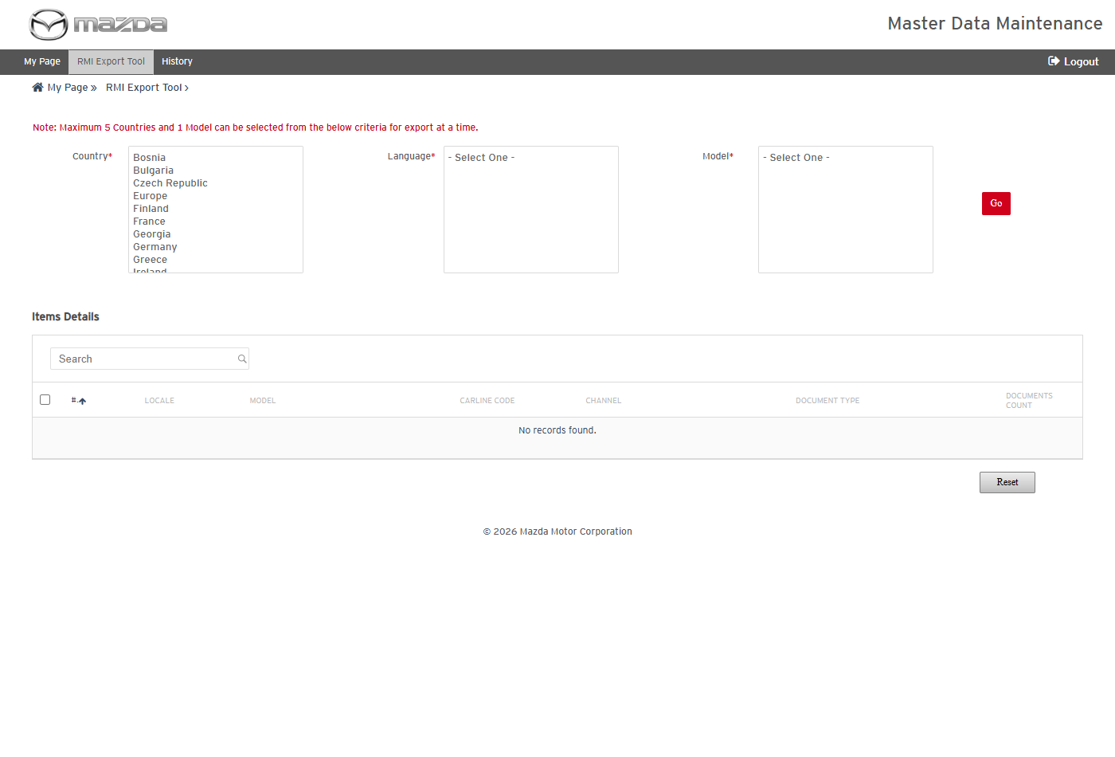
RMI Export Tool
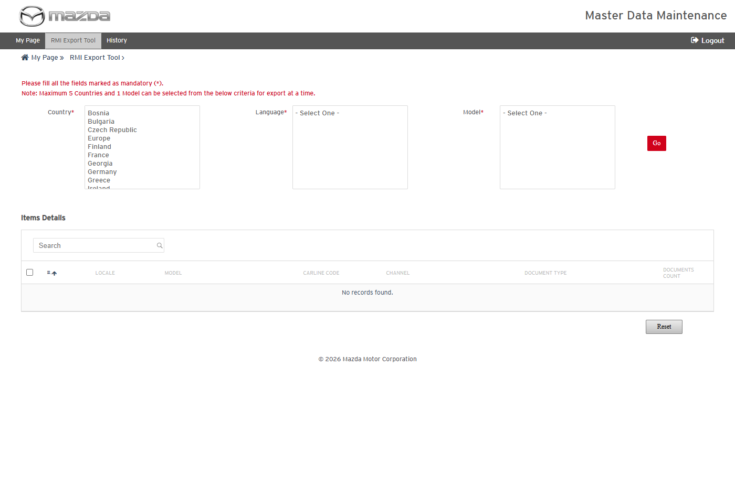
Mandatory field message
Status: Pass
Remarks:

- User should be able to list the items of a model and schedule an RMI export.
Steps:
1. Select Country United Kingdom, Language English (en-UK) and Model BT-50_UP; click Go.
2. Select the SERVICE_INFORMATION / TECHNICAL_INFORMATION item and click Schedule.
Expected Result:
- Items Details lists the channel / document type items of the model with their document counts.
- "Schedule MGSS_RMI_EXPORT_303 scheduled successfully." is shown.
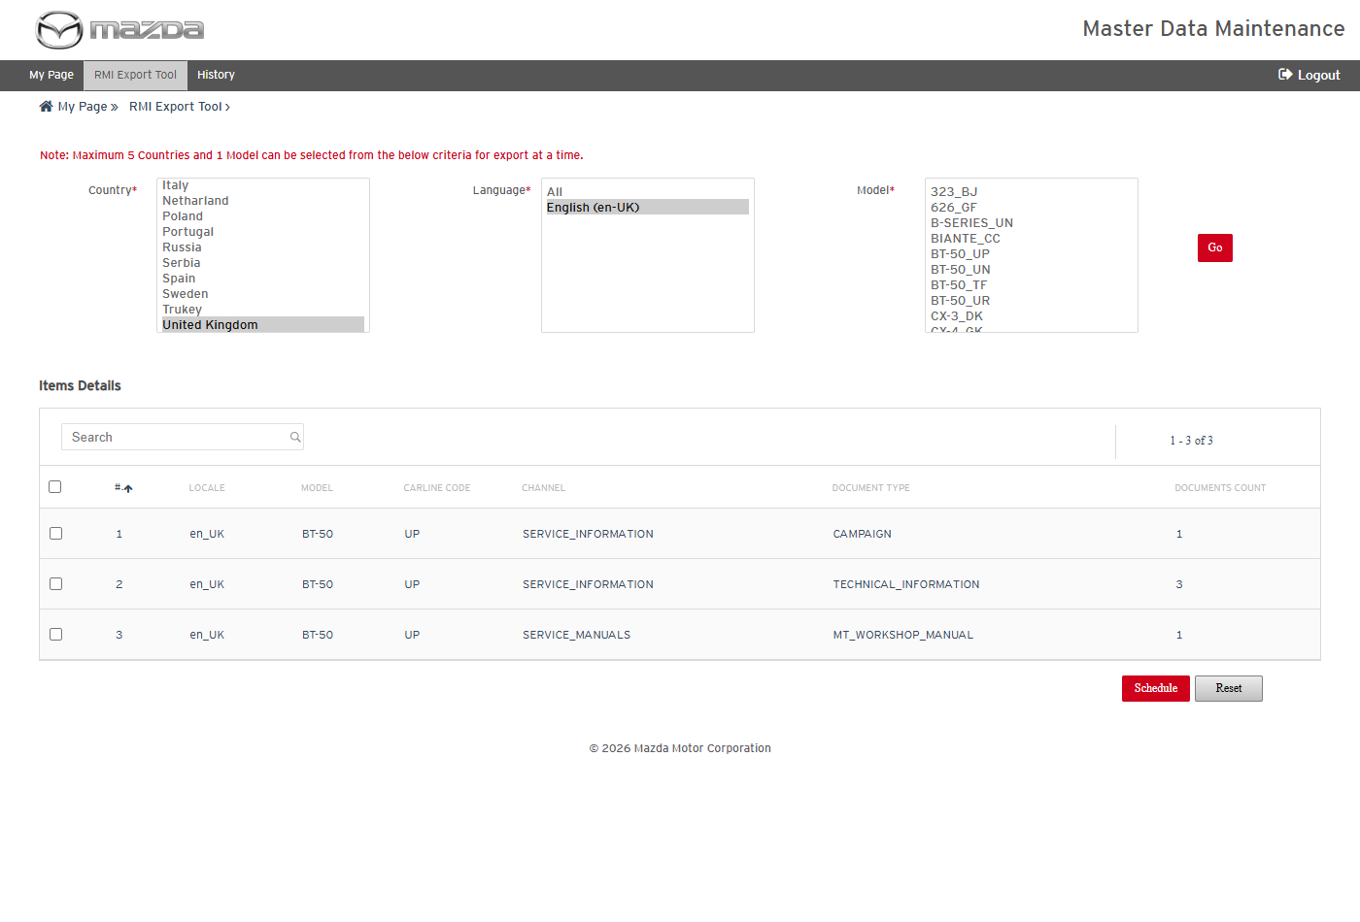
Items of BT-50_UP
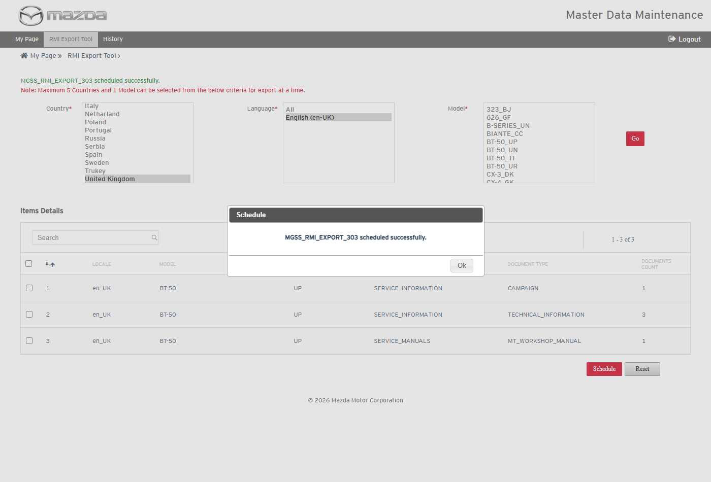
Export scheduled
Status: Pass
Remarks:

- User should be able to view the RMI export history, item details and report summary.
Steps:
1. Click History in the top menu.
2. Click the schedule name, then the Job Summary icon.
Expected Result:
- MGSS_RMI_EXPORT_303 shows Documents 3 / 3 / 0, Content Export Progress Completed and Job Status Success.
- Item Details and Reports Summary Details show the item and the Document Extraction Report with 3 success transactions.
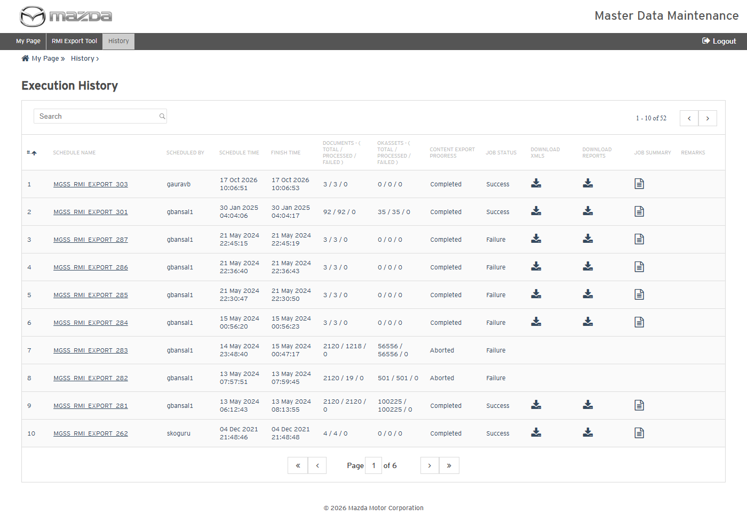
RMI Export History
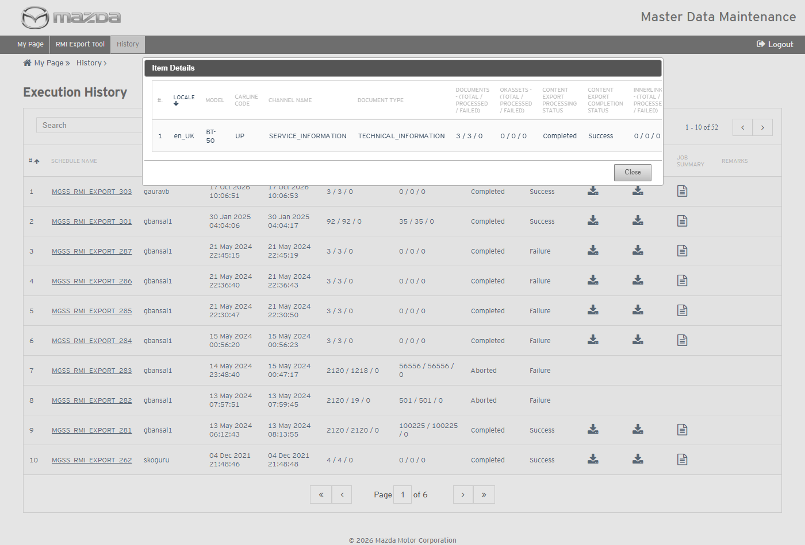
Item Details
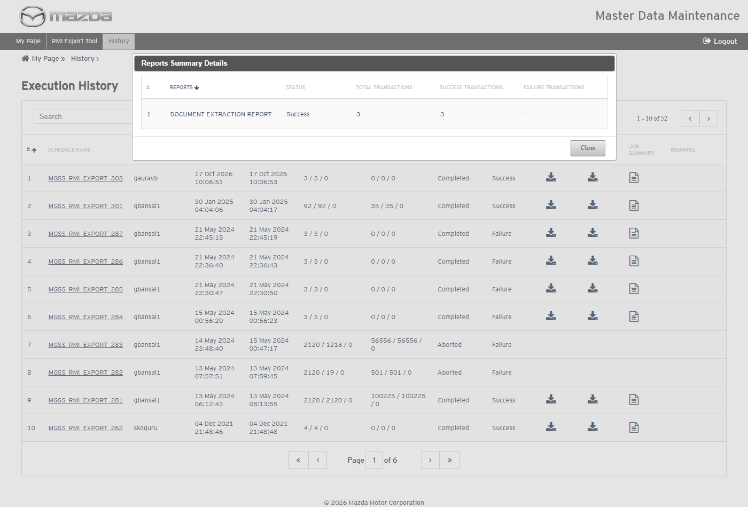
Reports Summary Details
Status: Pass
Remarks:

- User should be able to download the RMI export report and the extracted content.
Steps:
1. Click the Download Reports and Download XMLs icons of the schedule.
2. Open the files.
Expected Result:
- The Document Extraction Report lists SI1124, SI1141 and SI1143 with Processing Status Success.
- The XML zip holds one XML per document under locale / model / channel / document type, plus the view content details Excel.
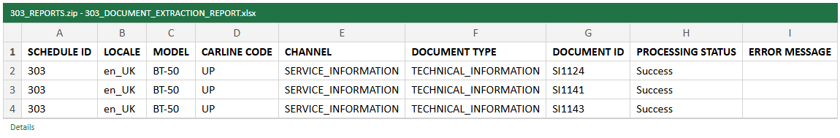
Document Extraction Report
Extracted content (XML zip)
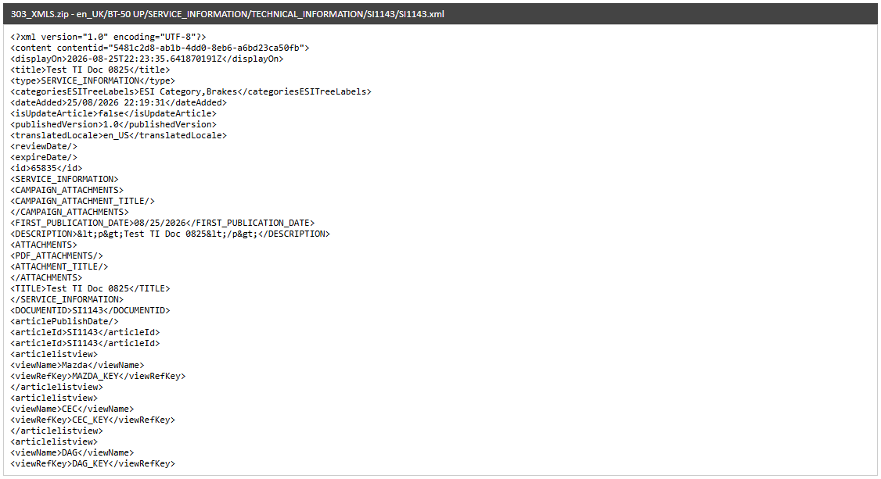
Extracted XML - SI1143
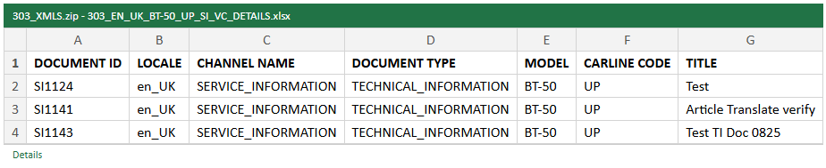
View content details
Status: Pass
Remarks:

Service Information Data Import
The cases below are executed with Country United States and Language English Us, importing the screen's Sample Document as a New Document.
- System should not upload without a Word file.
Steps:
1. From My Page > Tools, Import and Export, click Service Information Data Import.
2. Select the Country and Language and click Upload without a file.
Expected Result: "Please upload a valid Doc file." is shown.
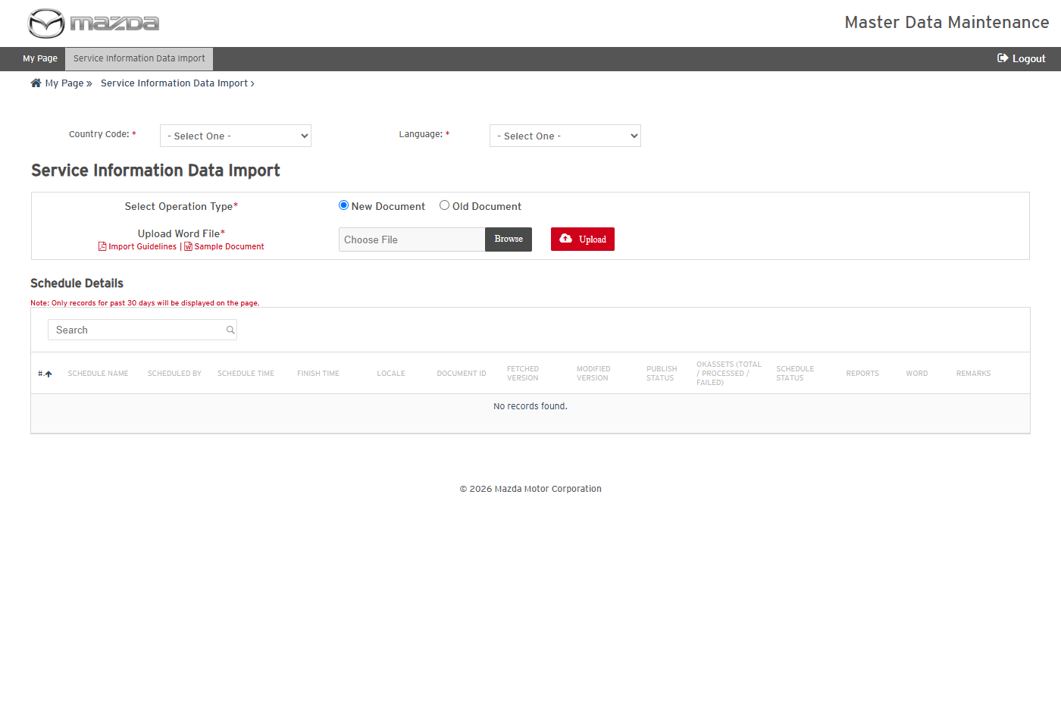
Service Information Data Import
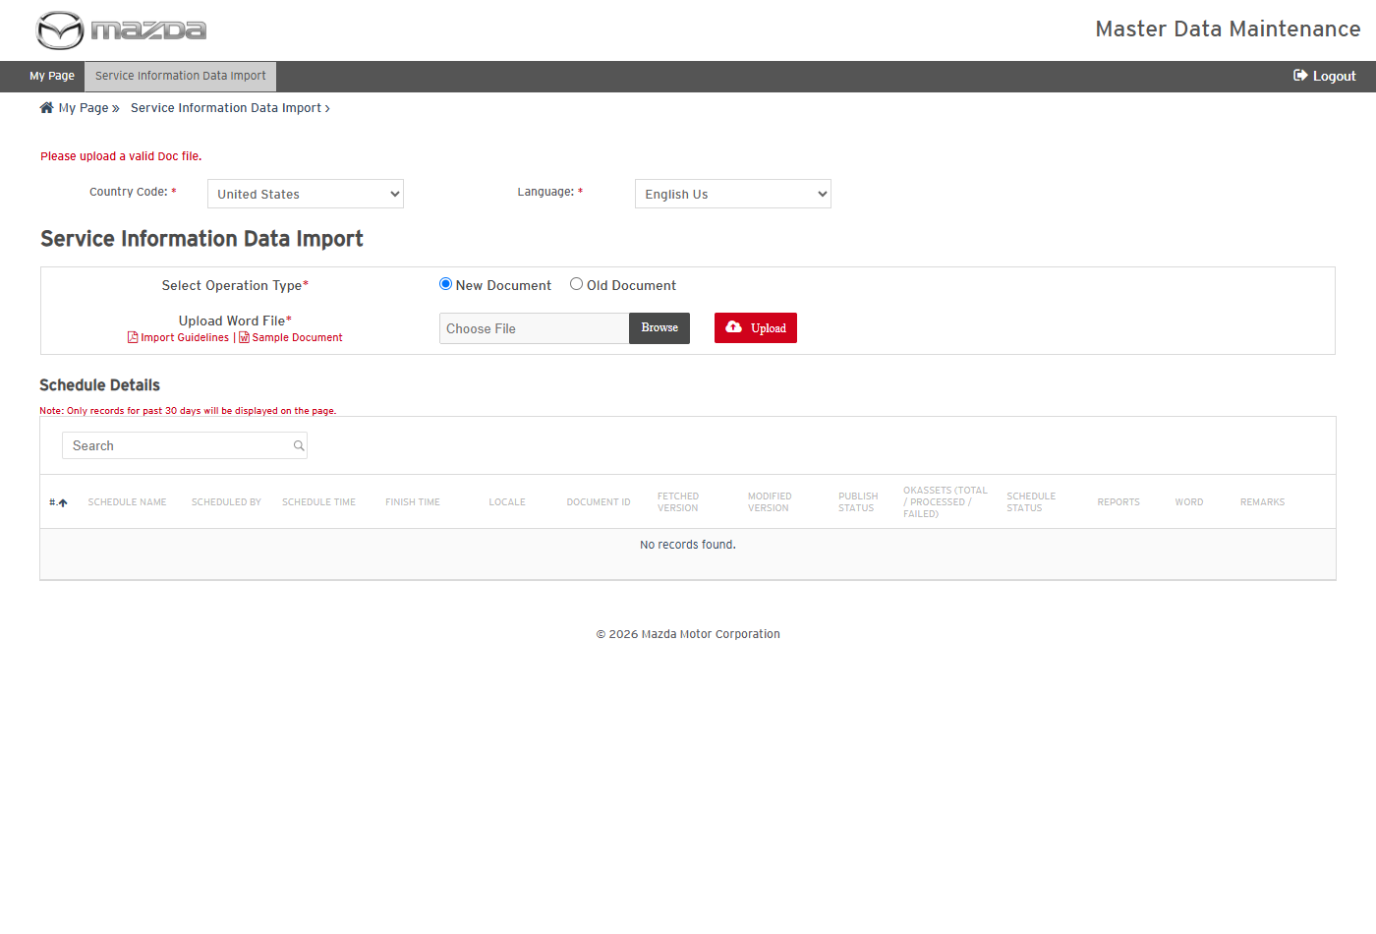
Validation message
Status: Pass
Remarks:

- User should be able to import a Word file as a new Service Information document.
Steps:
1. Select Operation Type New Document and choose the Word file (Sample Document).
2. Click Upload.
Expected Result:
- "SI_DL_SCH_93 scheduled successfully." is shown.
- The schedule completes with Document Id SI101014, Modified Version 0.1, Publish Status N and Schedule Status Success (the new document is saved as a draft for review and publishing).
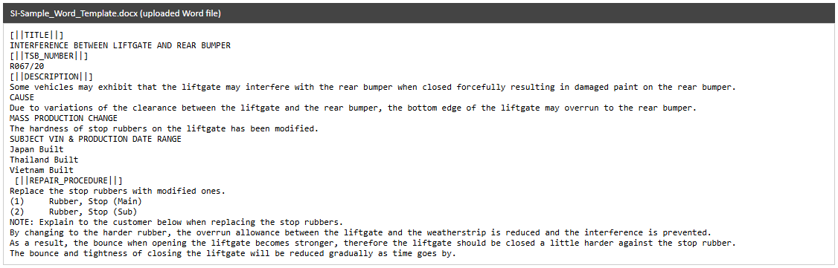
Uploaded Word file
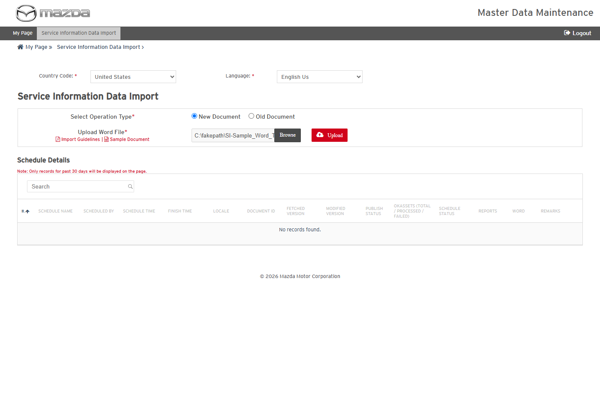
New Document selected
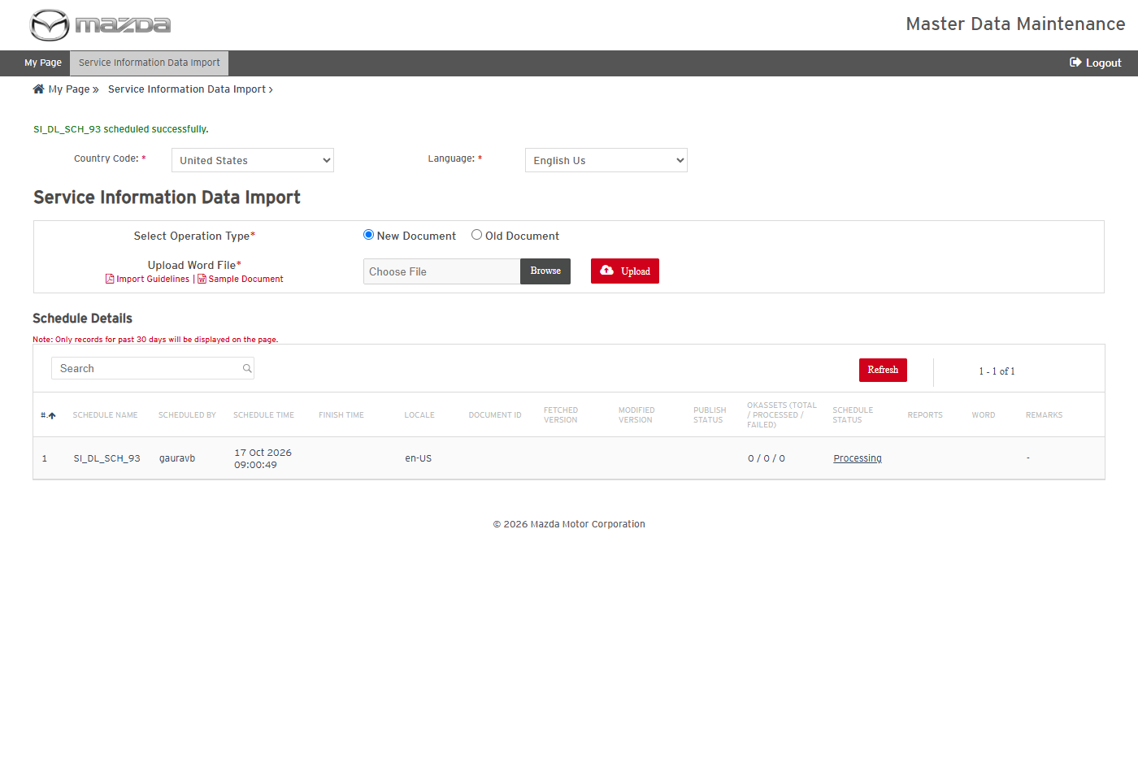
Import scheduled
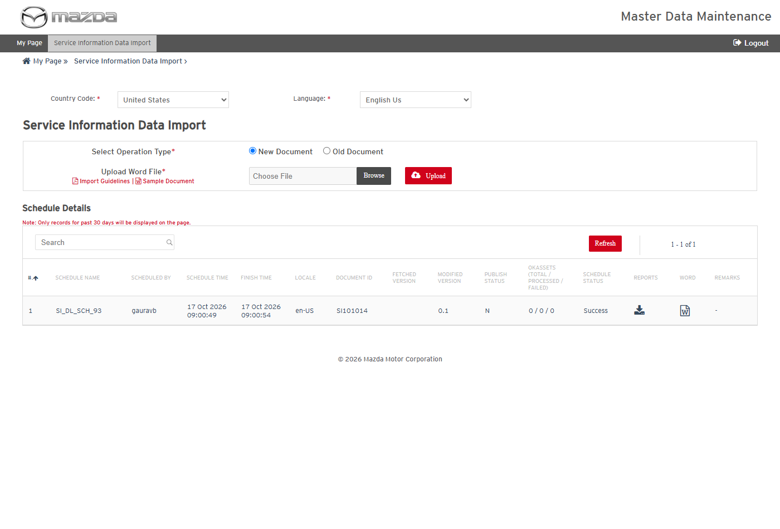
Import completed
Status: Pass
Remarks:

- User should be able to download the import report and the converted content.
Steps:
1. Click the Reports and Word icons of SI_DL_SCH_93.
2. Open the files.
Expected Result:
- The transaction report lists SI101014 (en-US, New Document, version 0.1) with Processing Status Success.
- The converted content shows the sections of the Word file (title, TSB number, description, repair procedure and others).
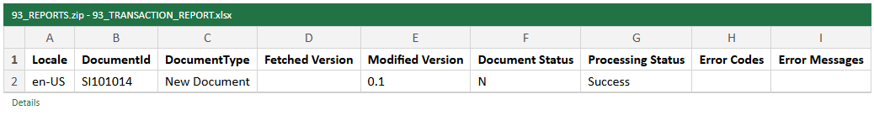
Transaction report
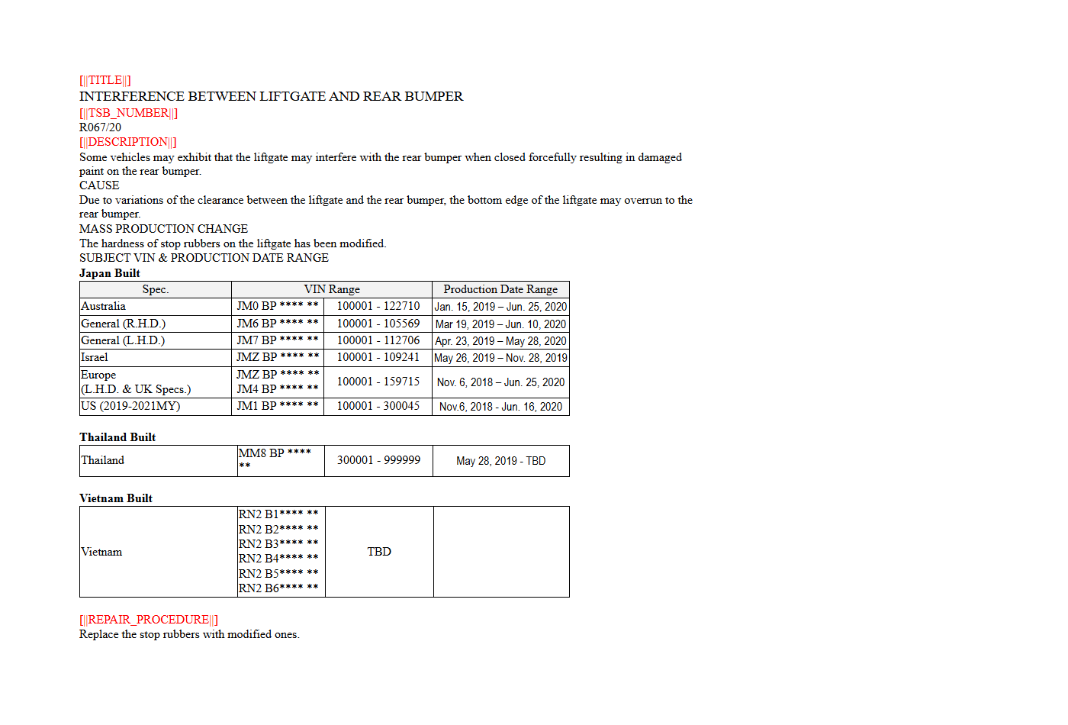
Converted content
Status: Pass
Remarks:

MNAO Data Export Tool
The cases below are executed with Country United States, Language English Us (en-US), Data Extraction Type Full Data and Model B1800.
- System should not list items without the mandatory fields.
Steps:
1. From My Page > Tools, Import and Export, click MNAO Data Export Tool.
2. Click Go.
Expected Result: "Please fill all the fields marked as mandatory (*)." is shown.
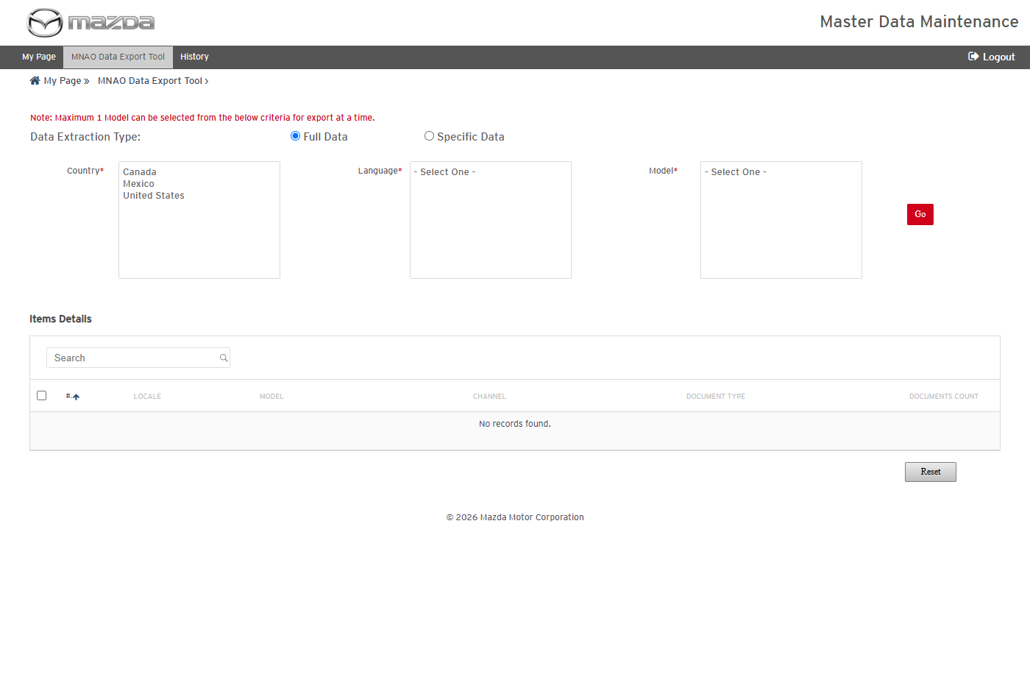
MNAO Data Export Tool
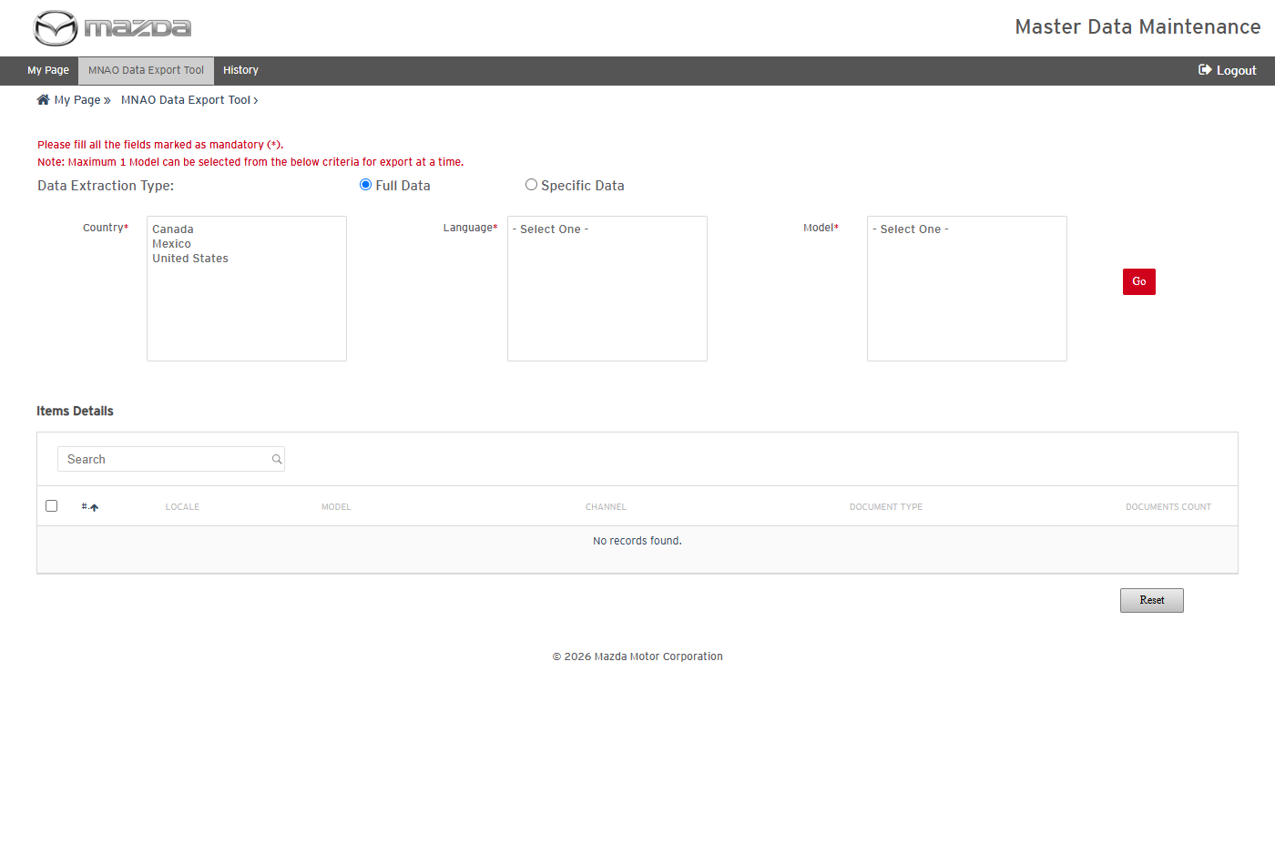
Mandatory field message
Status: Pass
Remarks:

- User should be able to list the items of a model and schedule an MNAO export.
Steps:
1. Select Country United States, Language English Us (en-US) and Model B1800; click Go.
2. Select the SERVICE_INFORMATION / SERVICE_ALERT item and click Schedule.
Expected Result:
- Items Details lists the channel / document type items of the model with their document counts.
- "Schedule MGSS_MNAO_EXPORT_B1800_32 scheduled successfully." is shown.
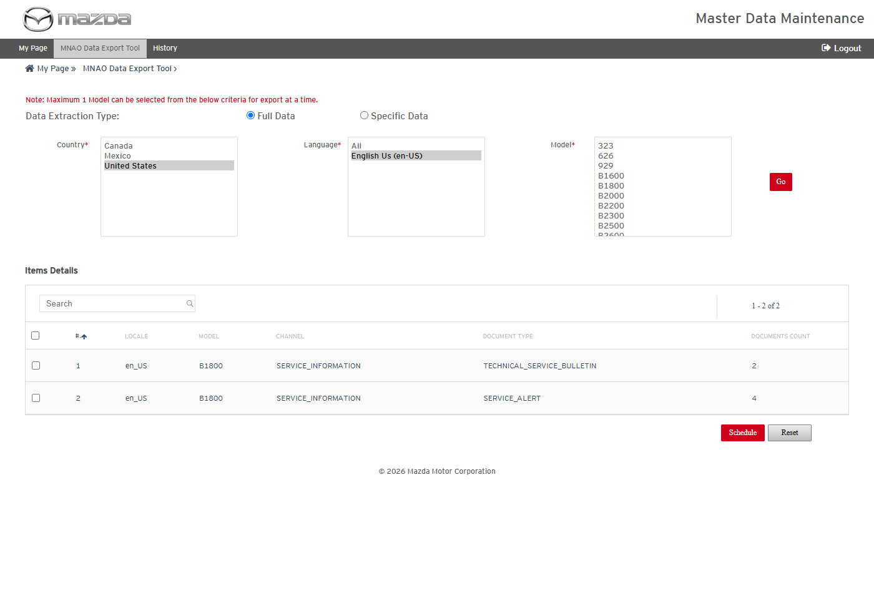
Items of B1800
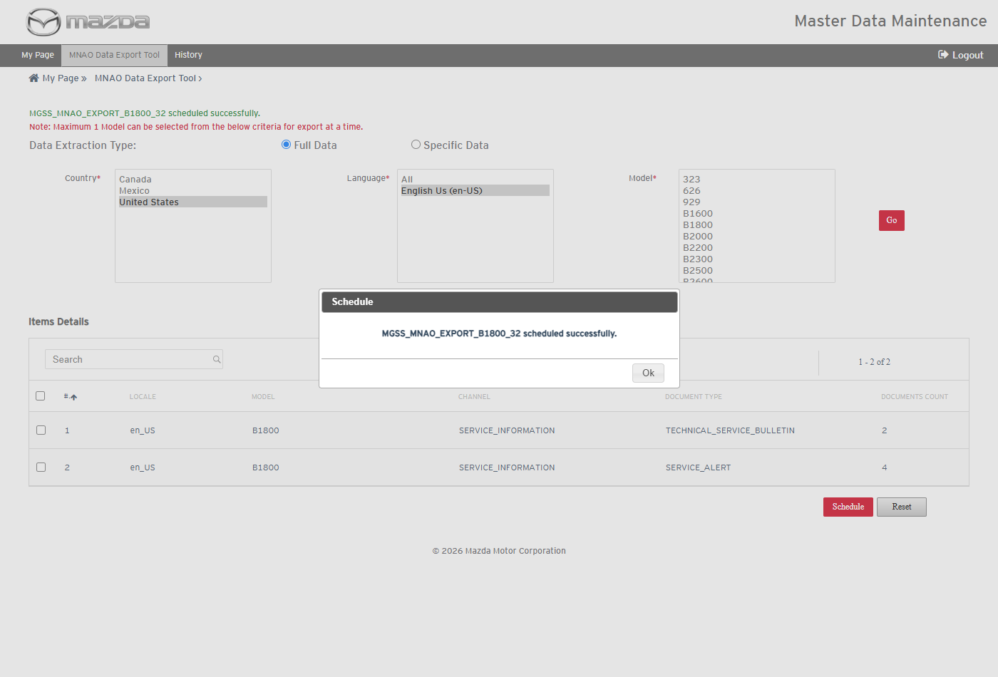
Export scheduled
Status: Pass
Remarks:

- User should be able to view the MNAO export history, item details and report summary.
Steps:
1. Click History in the top menu.
2. Click the schedule name, then the Job Summary icon.
Expected Result:
- MGSS_MNAO_EXPORT_B1800_32 shows Documents 4 / 4 / 0, OKAssets 2 / 2 / 0, Content Export Progress Completed and Job Status Success.
- Reports Summary Details shows the Document Extraction (4), Files Transaction (2) and Inner Links Transaction (8) reports, all Success.
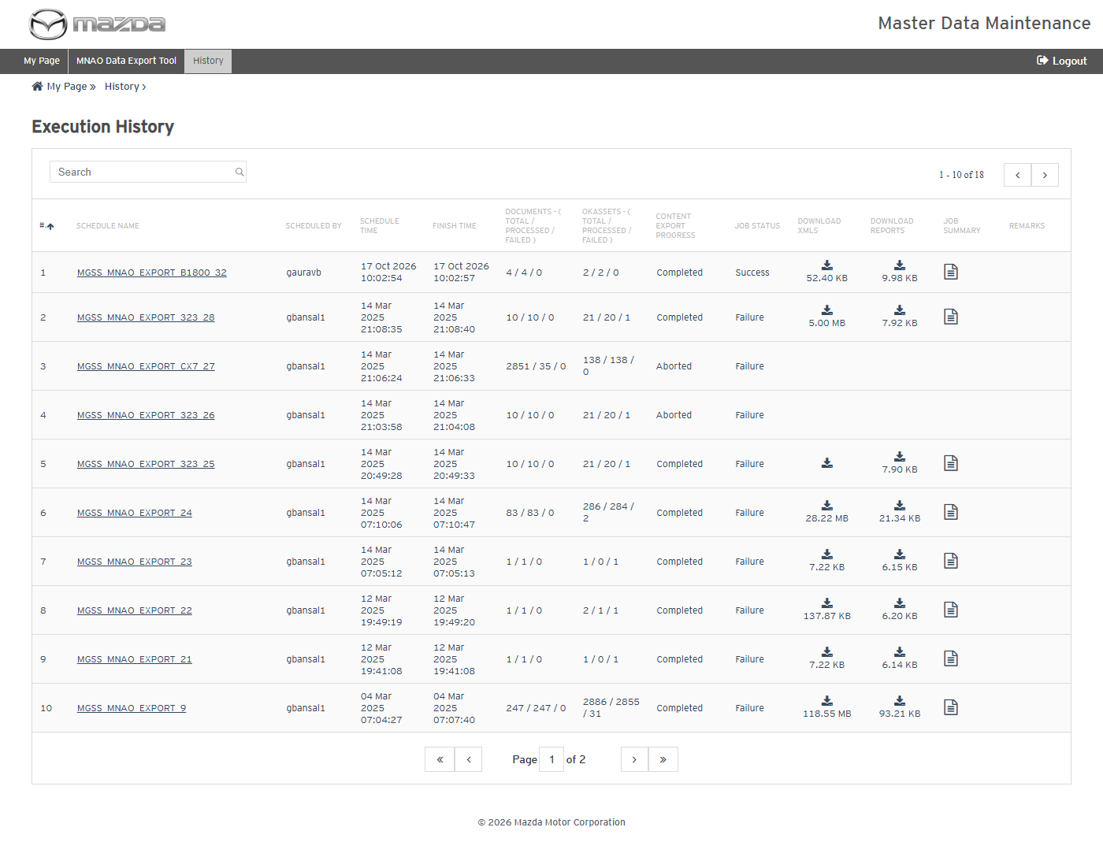
MNAO Export History
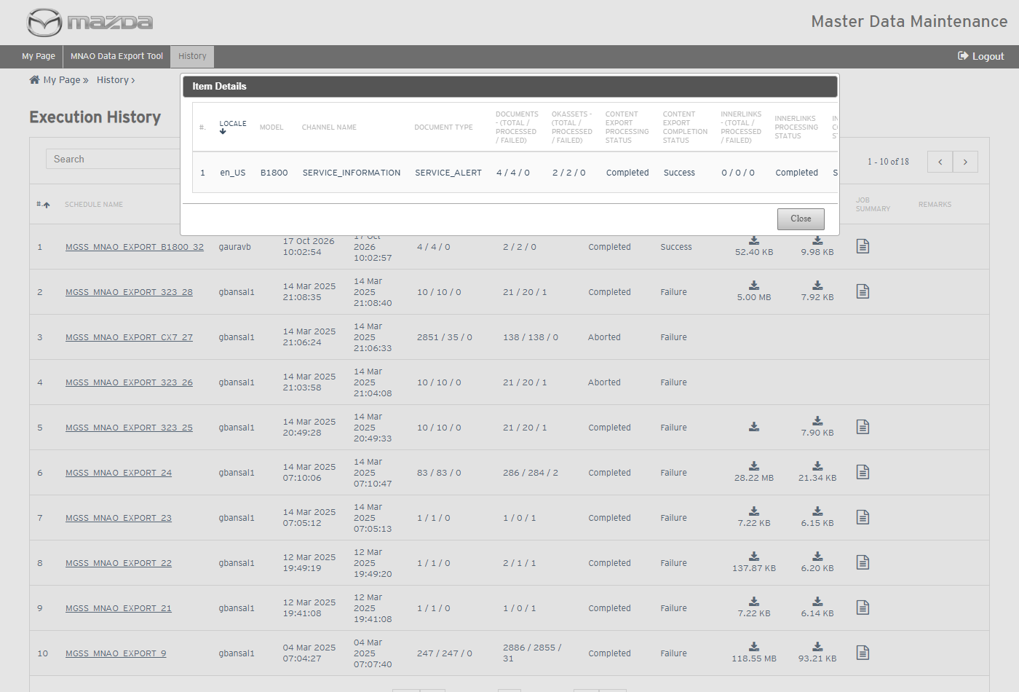
Item Details
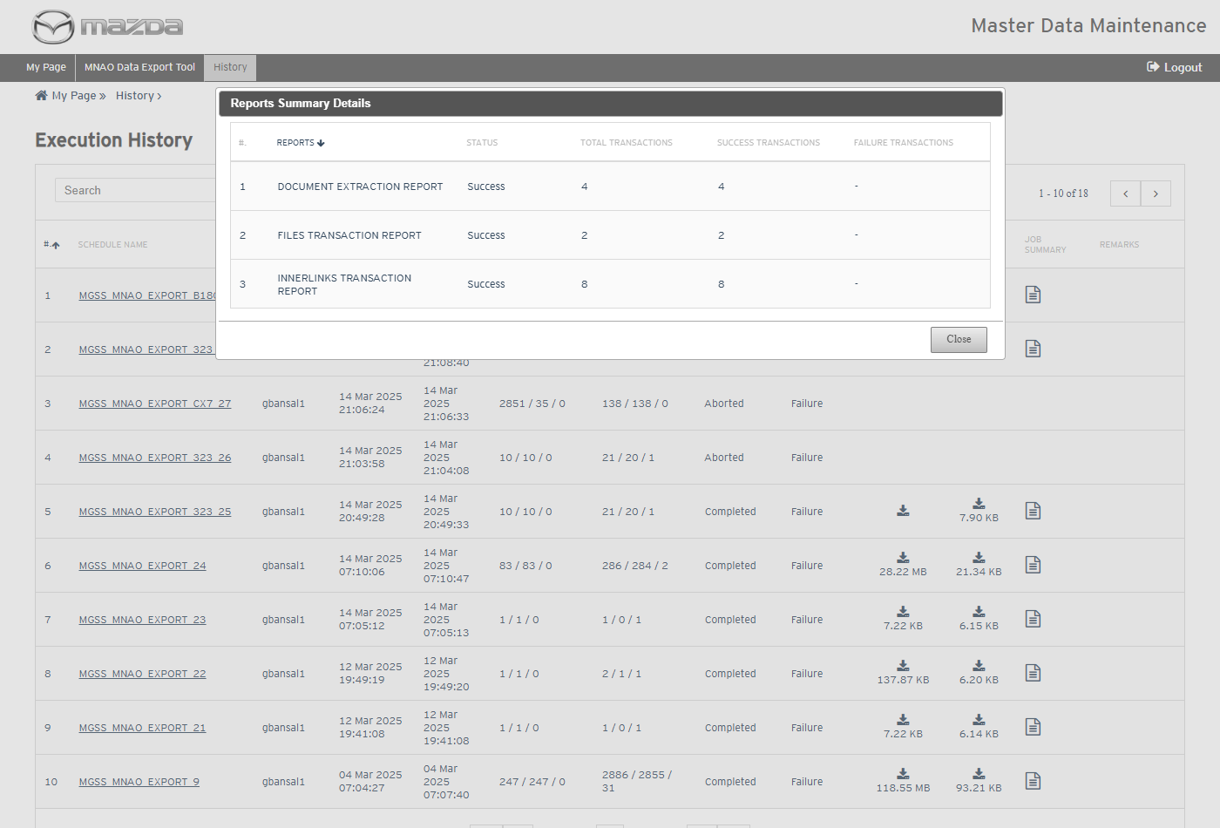
Reports Summary Details
Status: Pass
Remarks:

- User should be able to download the MNAO export reports and the extracted content.
Steps:
1. Click the Download Reports and Download XMLs icons of the schedule.
2. Open the files.
Expected Result:
- The reports list the 4 documents, the 2 images and the inner links with Processing Status Success.
- The XML zip holds one XML per document (image paths rewritten to the exported OkAssets folder), the exported images and the view content model year / VIN details.
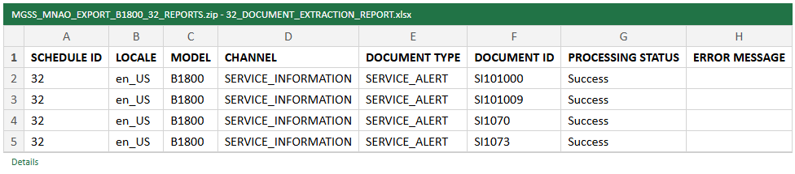
Document Extraction Report
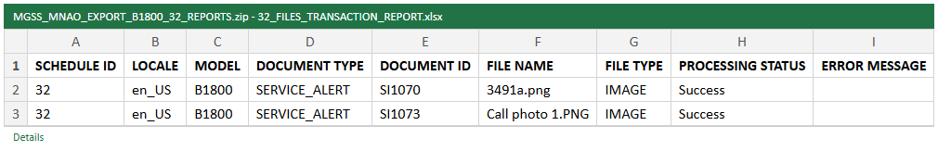
Files Transaction Report
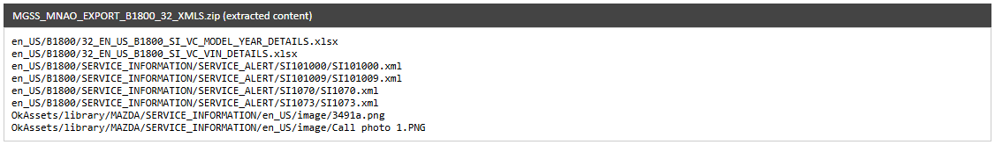
Extracted content (XML zip)
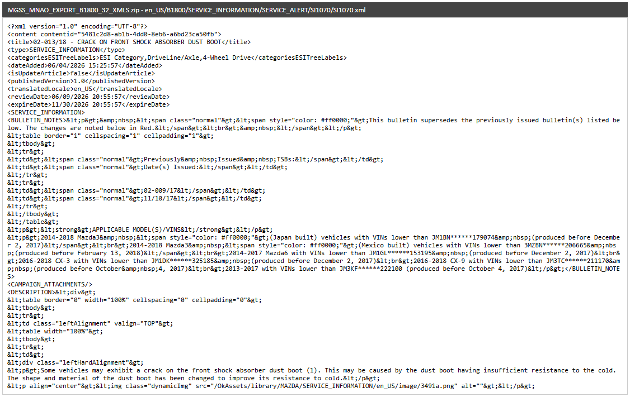
Extracted XML - SI1070
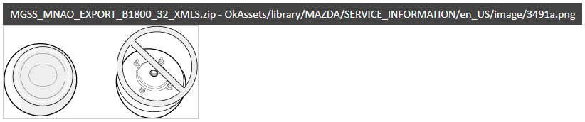
Exported image - 3491a.png
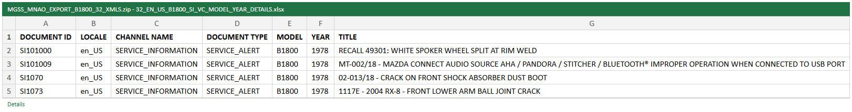
View content model year details
Status: Pass
Remarks:

MGSS Bulk Data Extract & Transfer Tool
- User should be able to view the auto scheduler settings and model details.
Steps:
1. From My Page > Tools, Import and Export, click MGSS Bulk Data Extract & Transfer Tool.
Expected Result: Auto Scheduler Settings (Day / Hour) and Model Details list each EN_US model with its schedule time, last executed time and the Run On Demand / Reset For Full Extract / Update For Delta Extract actions.
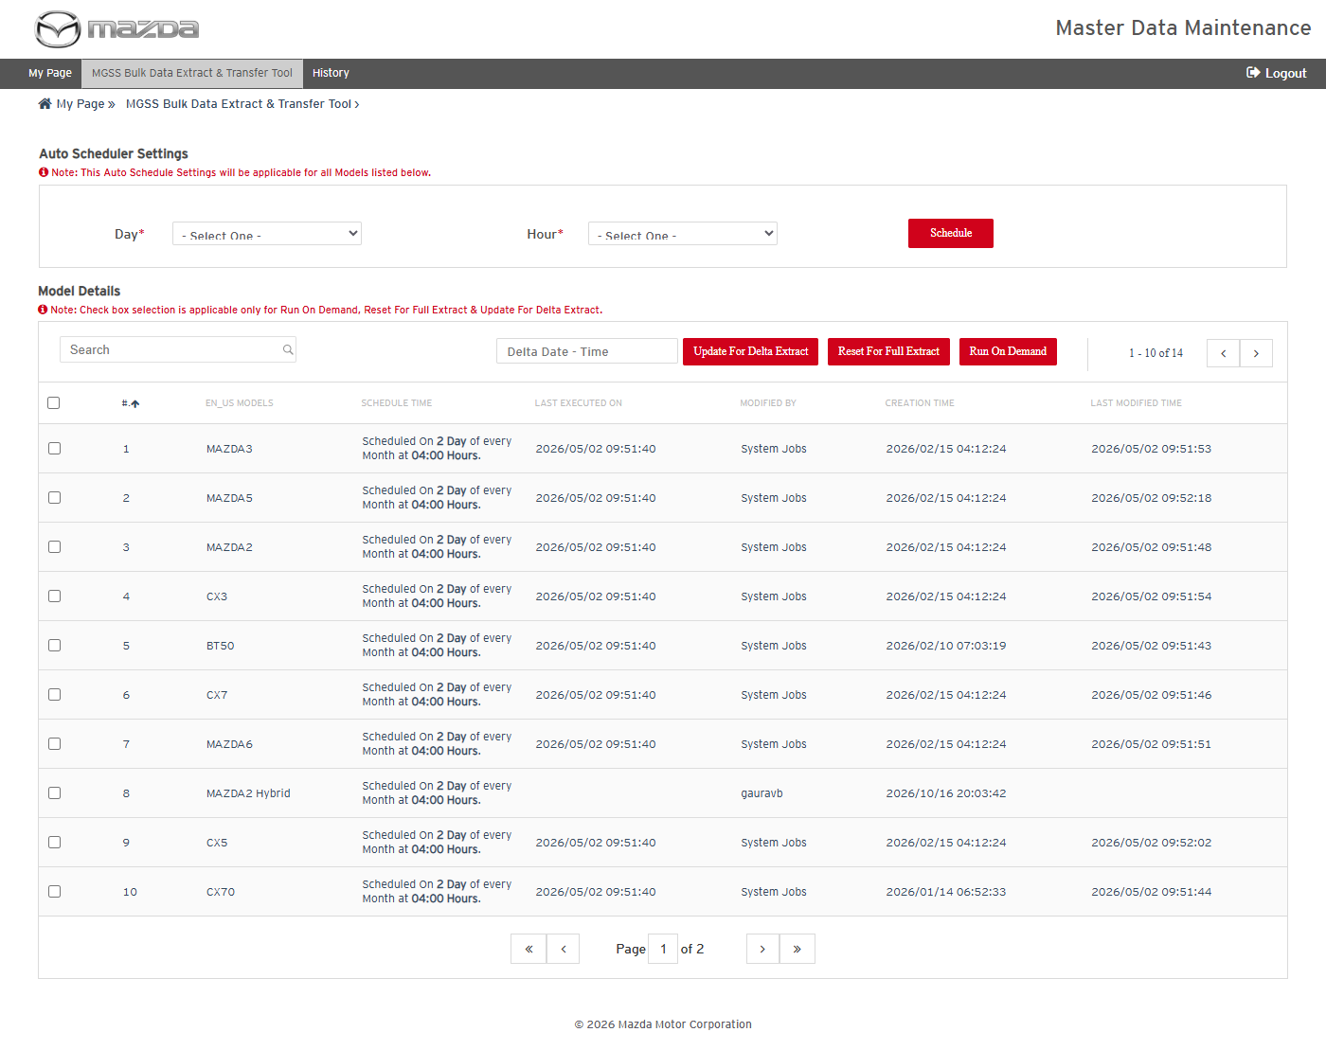
MGSS Bulk Data Extract & Transfer Tool
Status: Pass
Remarks:

- System should not save the auto schedule without Day and Hour.
Steps:
1. Leave Day and Hour as - Select One - and click Schedule.
Expected Result: "Please fill all the fields marked as mandatory (*)." is shown.
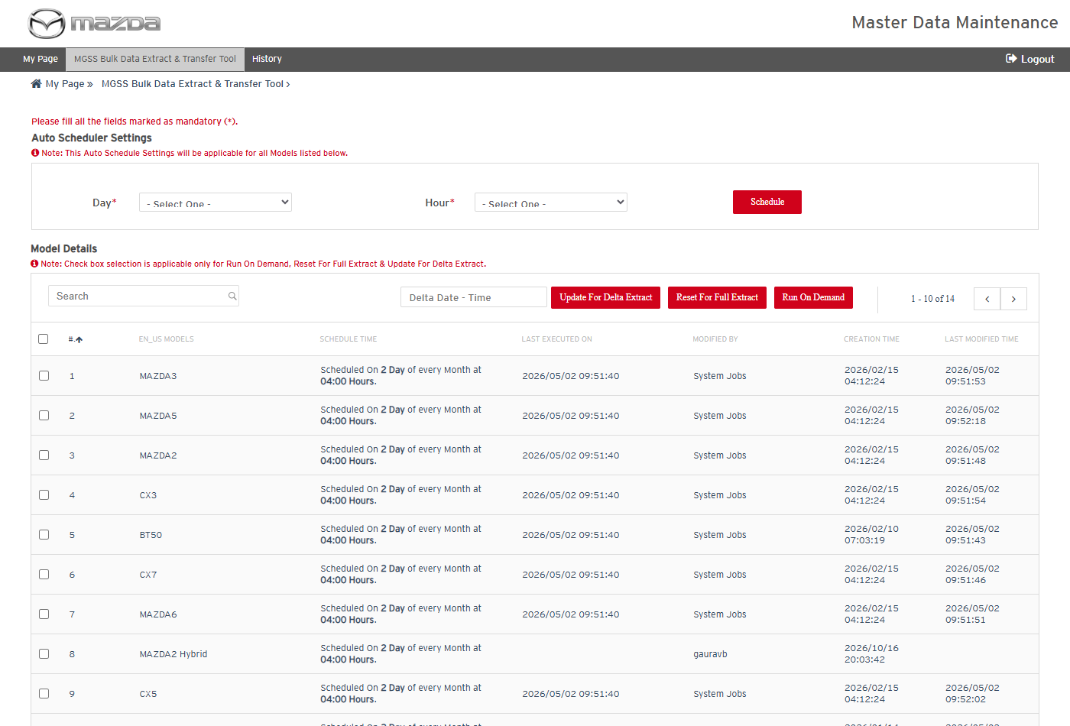
Mandatory field message
Status: Pass
Remarks:

- User should be able to view the extract and transfer history.
Steps:
1. Click History in the top menu.
Expected Result: Execution History shows the From / To Date search and the job columns (documents, inner links, OKAssets, delete, transfer, statuses, reports and summary).
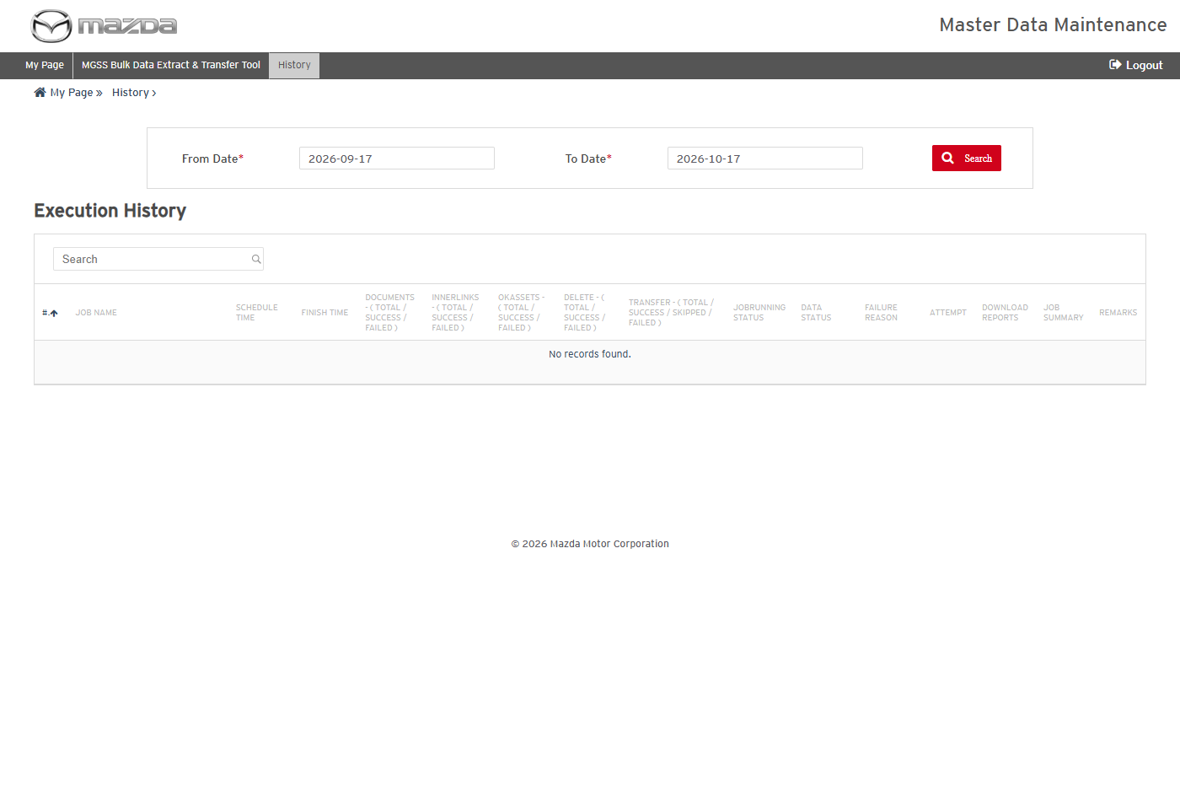
Execution History
Status: Pass
Remarks:

